 |  | Question Type | Difficulty | LO1: DM, DL, Manuf. overhead | LO2: Period and product costs | LO3: Variable, fixed, and mixed costs | LO4: High-low method | LO5: Income statement formats | LO6: Direct and indirect costs | LO7: Decision-making cost classifications | Professional Exam Adapted | ID | Origin | CMA/CPA origin
 | 1 | T/F | E | x |  | x |  |  |  |  |  | 8/e:ATB2-2 | David Keyes
 | 2 | T/F | E | x |  |  |  |  |  |  |  | 3/e:2-TF9 | Authors
 | 3 | T/F | E | x |  |  |  |  |  |  |  | 3/e:2-TF11 | Authors
 | 4 | T/F | E |  | x |  |  |  |  |  |  | 1/e:Exam#1-I10 | Authors
 | 5 | T/F | M |  | x |  |  |  |  |  |  | 3/e:2-TF5 | Authors
 | 6 | T/F | H |  | x |  |  |  |  |  |  | 3/e:2-TF13 | Authors
 | 7 | T/F | M |  | x |  |  |  |  |  |  | 1/e:Exam#1-I6 | Authors
 | 8 | T/F | E |  | x |  |  |  |  |  |  | 8/e:ATB2-1 | David Keyes
 | 9 | T/F | E |  |  | x |  |  |  |  |  | 3/e:2-TF4 | Authors
 | 10 | T/F | E |  |  | x |  |  |  |  |  | 8/e:ATB2-6 | David Keyes
 | 11 | T/F | E |  |  | x |  |  |  |  |  | 4/e:30 | Authors
 | 12 | T/F | E |  |  | x |  |  |  |  |  | 3/e: 5-7 | Authors
 | 13 | T/F | M |  |  | x |  |  |  |  |  | 3/e: 5-6 | Authors
 | 14 | T/F | E |  |  | x |  |  |  |  |  | 4/e: 5-251 | Authors
 | 15 | T/F | M |  |  | x |  |  |  |  |  | 2/e: 4-3 | Authors
 | 16 | T/F | E |  |  | x |  |  |  |  |  | 2/e: 4-1 | Authors
 | 17 | T/F | E |  |  | x |  |  |  |  |  | 3-15-2010 TF A | E.N.
 | 18 | T/F | H |  |  | x |  |  |  |  |  | 8/e:ATB6-07 | David Keyes
 | 19 | T/F | E |  |  | x |  |  |  |  |  | 2/e: 4-9 | Authors
 | 20 | T/F | E |  |  |  |  | x |  |  |  | 3/14/2010 A1 | E.N.
 | 21 | T/F | E |  |  |  |  | x |  |  |  | 3/14/2010 C2 | E.N.
 | 22 | T/F | E |  |  |  |  | x |  |  |  | 3/14/2010 E1 | E.N.
 | 23 | T/F | E |  |  |  |  | x |  |  |  | 3/14/2010 G2 | E.N.
 | 24 | T/F | E |  |  |  |  | x |  |  |  | 3/14/2010 J1 | E.N.
 | 25 | T/F | E |  |  |  |  | x |  |  |  | 3/14/2010 L2 | E.N.
 | 26 | T/F | M |  |  |  |  |  | x |  |  | 4/6/97C | E.N.
 | 27 | T/F | H |  |  |  |  |  | x |  |  | 4/6/97D | E.N.
 | 28 | T/F | H |  |  |  |  |  | x |  |  | 4/6/97E | E.N.
 | 29 | T/F | E |  |  |  |  |  |  | x |  | 8/e:ATB2-9 | David Keyes
 | 30 | Conceptual M/C | H | x | x |  |  |  |  | x |  | 8/e: ATB2-13 | David Keyes
 | 31 | Conceptual M/C | M | x | x |  |  |  |  |  |  | 5/e: 2-58 | Authors
 | 32 | Conceptual M/C | M | x |  |  |  |  | x |  |  | 5/e: 2-27 | Authors
 | 33 | Conceptual M/C | M | x |  |  |  |  |  |  |  | 5/e: 2-70 | Authors
 | 34 | Conceptual M/C | M | x |  |  |  |  |  |  |  | 4/e: 50 | Authors
 | 35 | Conceptual M/C | E | x |  |  |  |  |  |  |  | 3/e: 2-MC8 | Authors
 | 36 | Conceptual M/C | E | x |  |  |  |  |  |  |  | 3/e: 2-MC7 | Authors
 | 37 | Conceptual M/C | M |  | x | x |  |  |  |  |  | 8/e: ATB2-14 | David Keyes
 | 38 | Conceptual M/C | E |  | x |  |  |  |  |  |  | 4/e: 43 | Authors
 | 39 | Conceptual M/C | E |  | x |  |  |  |  |  |  | 4/e: 84 | Authors
 | 40 | Conceptual M/C | M |  | x |  |  |  |  |  |  | 4/e: 44 | Authors
 | 41 | Conceptual M/C | E |  | x |  |  |  |  |  |  | 3/e: 2-MC6 | Authors
 | 42 | Conceptual M/C | E |  | x |  |  |  |  |  |  | LD9e:CH02Q13 | Larry Deppe
 | 43 | Conceptual M/C | M |  | x |  |  |  |  |  | CMA | CMA,6/96,Part3,Q18 | CMA | CMA,6/96,Part3,Q18
 | 44 | Conceptual M/C | H |  |  | x |  |  |  |  |  | 5/e: 2-29 | Authors
 | 45 | Conceptual M/C | M |  |  | x |  |  |  |  |  | 5/e: 2-36 | Authors
 | 46 | Conceptual M/C | M |  |  | x |  |  |  |  |  | 3-15-2010 TF B | E.N.
 | 47 | Conceptual M/C | H |  |  | x |  |  |  |  |  | 8/e: ATB2-18 | David Keyes
 | 48 | Conceptual M/C | E |  |  | x |  |  |  |  |  | 3-15-2010 TF C | E.N.
 | 49 | Conceptual M/C | E |  |  | x |  |  |  |  |  | 4/e: 5-295 | Authors
 | 50 | Conceptual M/C | E |  |  | x |  |  |  |  |  | 5/e: 5-16 | Authors
 | 51 | Conceptual M/C | H |  |  | x |  |  |  |  |  | 5/e: 5-17 | Authors
 | 52 | Conceptual M/C | H |  |  |  |  |  | x |  |  | 4/6/97B | E.N.
 | 53 | Conceptual M/C | M |  |  |  |  |  |  | x |  | 2/e: 2-MC12 | Authors
 | 54 | Conceptual M/C | E |  |  |  |  |  |  | x |  | 3/e: 2-MC10 | Authors
 | 55 | Conceptual M/C | E |  |  |  |  |  |  | x | CMA | CMA,6/96,Part4,Q19 | CMA | CMA,6/96,Part4,Q19
 | 56 | M/C | M | x | x |  |  |  |  |  |  | New,11/9/95,D9 | E.N.
 | 57 | M/C | M | x | x |  |  |  |  |  |  | New,11/9/95,E9 | E.N.
 | 58 | M/C | H | x |  |  |  |  |  |  |  | New,11/9/95,C9 | E.N.
 | 59 | M/C | H | x |  |  |  |  |  |  |  | New,11/8/95,A8 | E.N.
 | 60 | M/C | H | x |  |  |  |  |  |  |  | New,11/9/95,B9 | E.N.
 | 61 | M/C | M |  | x |  |  |  |  |  |  | LD9e:CH02Q11 | Larry Deppe
 | 62 | M/C | H |  |  | x | x | x |  |  |  | EN 12-23-2002 SPI5 | E.N.
 | 63 | M/C | M |  |  | x | x |  |  |  |  | EN 12-23-2002 SPG5 | E.N.
 | 64 | M/C | H |  |  | x | x |  |  |  |  | EN 12-23-2002 SPB5 | E.N.
 | 65 | M/C | H |  |  | x | x |  |  |  |  | EN 12-23-2002 SPC5 | E.N.
 | 66 | M/C | M |  |  | x | x |  |  |  |  | EN 12-23-2002 SPE5 | E.N.
 | 67 | M/C | M |  |  | x | x |  |  |  |  | EN 12-23-2002 SPD5 | E.N.
 | 68 | M/C | M |  |  | x | x |  |  |  |  | EN 12-23-2002 SPH5 | E.N.
 | 69 | M/C | M |  |  | x | x |  |  |  |  | EN 12-23-2002 SPF5 | E.N.
 | 70 | M/C | H |  |  | x | x |  |  |  |  | EN 12-23-2002 SPA5 | E.N.
 | 71 | M/C | M |  |  | x | x |  |  |  |  | LD9e:CH05Q7 | Larry Deppe
 | 72 | M/C | H |  |  | x | x |  |  |  |  | 5/e: 5-35 | Authors
 | 73 | M/C | M |  |  | x |  |  |  |  |  | 11/e: ATB 5-30 | Antoinette Clegg
 | 74 | M/C | H |  |  | x |  |  |  |  |  | 1/e: Achievement-6 | Authors
 | 75 | M/C | E |  |  | x |  |  |  |  |  | 8/22/2004 Single MC K4 | E.N.
 | 76 | M/C | E |  |  | x |  |  |  |  |  | 5/e: 5-63 | Authors
 | 77 | M/C | E |  |  | x |  |  |  |  |  | 4/e: 5-266 | Authors
 | 78 | M/C | E |  |  | x |  |  |  |  |  | 8/22/2004 Single MC I4 | E.N.
 | 79 | M/C | E |  |  | x |  |  |  |  |  | 1/e: 5-9 | Authors
 | 80 | M/C | E |  |  | x |  |  |  |  |  | 1/e: Achievement-8 | Authors
 | 81 | M/C | E |  |  | x |  |  |  |  |  | 8/22/2004 Single MC J4 | E.N.
 | 82 | M/C | E |  |  |  | x |  |  |  |  | 08/21/2004 Single MC C4 | E.N.
 | 83 | M/C | E |  |  |  | x |  |  |  |  | 08/21/2004 Single MC A4 | E.N.
 | 84 | M/C | E |  |  |  | x |  |  |  |  | 11/e: ATB 5-25 | Antoinette Clegg
 | 85 | M/C | E |  |  |  | x |  |  |  |  | 3/e: 5-9 | Authors
 | 86 | M/C | E |  |  |  | x |  |  |  |  | 2/e: 4-5 | Authors
 | 87 | M/C | E |  |  |  | x |  |  |  |  | 08/21/2004 Single MC B4 | E.N.
 | 88 | M/C | M |  |  |  | x |  |  |  |  | LD9e:CH05Q4 | Larry Deppe
 | 89 | M/C | M |  |  |  |  | x |  |  |  | New,11/9/95,H9 | E.N.
 | 90 | M/C | E |  |  |  |  | x |  |  |  | New,11/9/95,G9 | E.N.
2-1 | 91-93 | Multipart M/C | M | x | x |  |  |  |  |  |  | 8/3/2004 Multi MC P4 | E.N.
2-2 | 94-96 | Multipart M/C | M | x | x |  |  |  |  |  |  | 8/3/2004 Multi MC O4 | E.N.
2-3 | 97-98 | Multipart M/C | E | x |  |  |  |  |  |  |  | 8/3/2004 Multi MC E4 | E.N.
2-4 | 99-100 | Multipart M/C | E | x |  |  |  |  |  |  |  | 8/3/2004 Multi MC M4 | E.N.
2-5 | 101-103 | Multipart M/C | M |  |  | x | x | x |  |  |  | EN 12-23-2002 MPC5 | E.N.
2-6 | 104-106 | Multipart M/C | M |  |  | x | x |  |  |  |  | EN 12-23-2002 MPB4 | E.N.
2-7 | 107-109 | Multipart M/C | H |  |  | x | x |  |  |  |  | EN 12-23-2002 MPA5 | E.N.
2-8 | 110-111 | Multipart M/C | E |  |  | x |  |  |  |  |  | 8/22/2004 Multi MC L4 | E.N.
2-9 | 112-113 | Multipart M/C | E |  |  | x |  |  |  |  |  | 8/22/2004 Multi MC K4 | E.N.
2-10 | 114-115 | Multipart M/C | E |  |  | x |  |  |  |  |  | 8/3/2004 Multi MC U4 | E.N.
2-11 | 116-117 | Multipart M/C | E |  |  | x |  |  |  |  |  | 8/3/2004 Multi MC R4 | E.N.
2-12 | 118-119 | Multipart M/C | E |  |  | x |  |  |  |  |  | 8/3/2004 Multi MC S4 | E.N.
2-13 | 120-121 | Multipart M/C | E |  |  | x |  |  |  |  |  | 8/3/2004 Multi MC T4 | E.N.
2-14 | 122-123 | Multipart M/C | E |  |  | x |  |  |  |  |  | 8/22/2004 Multi MC J4 | E.N.
2-15 | 124-125 | Multipart M/C | E |  |  |  | x |  |  |  |  | 8/20/2004 Multi MC B4 | E.N.
2-16 | 126-127 | Multipart M/C | E |  |  |  | x |  |  |  |  | 8/21/2004 Multi MC C4 | E.N.
2-17 | 128-129 | Multipart M/C | E |  |  |  | x |  |  |  |  | 8/20/2004 Multi MC A4 | E.N.
2-18 | 130-132 | Multipart M/C | M-H |  |  |  | x |  |  |  |  | LD9e:CH05Q14-16 | Larry Deppe
2-19 | 133-134 | Multipart M/C | E |  |  |  |  | x |  |  |  | 3-15-2010 Multi MC C1 | E.N.
2-20 | 135-136 | Multipart M/C | M |  |  |  |  | x |  |  |  | 3-15-2010 Multi MC A1 | E.N.
2-21 | 137-138 | Multipart M/C | M |  |  |  |  | x |  |  |  | 3-15-2010 Multi MC B1 | E.N.
2-22 | 139-140 | Multipart M/C | E |  |  |  |  | x |  |  |  | 3-15-2010 Multi MC D1 | E.N.
2-23 | 141-142 | Multipart M/C | E |  |  |  |  | x |  |  |  | 8/3/2004 Multi MC N4 | E.N.
2-24 | 143-144 | Multipart M/C | E-M |  |  |  |  |  | x |  |  | 8/3/2004 Multi MC AA4 | E.N.
2-25 | 145-146 | Multipart M/C | E-M |  |  |  |  |  | x |  |  | 8/3/2004 Multi MC Z4 | E.N.
2-26 | 147-149 | Multipart M/C | E |  |  |  |  |  |  | x |  | 8/3/2004 Multi MC W4 | E.N.
2-27 | 150-152 | Multipart M/C | E |  |  |  |  |  |  | x |  | 8/3/2004 Multi MC V4 | E.N.
 | 153 | Problem | M | x | x | x |  |  |  | x |  | 1/e:Exam #1-III | Authors
 | 154 | Problem | M |  | x | x |  |  |  | x |  | 2/e:2-P2-2 | Authors
 | 155 | Problem | M |  | x |  |  |  |  |  |  | 8/3/2004 Problem F4 | E.N.
 | 156 | Problem | M |  | x |  |  |  |  |  |  | 8/3/2004 Problem E4 | E.N.
 | 157 | Problem | E |  |  | x |  |  |  |  |  | 5/e:5-56 | Authors
 | 158 | Problem | E |  |  | x |  |  |  |  |  | 8/22/2004 Problem L4 | E.N.
 | 159 | Problem | E |  |  | x |  |  |  |  |  | 8/22/2004 Problem M4 | E.N.
 | 160 | Problem | E |  |  | x |  |  |  |  |  | 8/4/2004 Problem N3 | E.N.
 | 161 | Problem | E |  |  | x |  |  |  |  |  | 8/4/2004 Problem M4 | E.N.
 | 162 | Problem | E |  |  |  | x |  |  |  |  | 8/21/2004 Problem B4 | E.N.
 | 163 | Problem | E |  |  |  | x |  |  |  |  | 8/21/2004 Problem A4 | E.N.
 | 164 | Problem | E |  |  |  | x |  |  |  |  | 8/21/2004 Problem C4 | E.N.
 | 165 | Problem | E |  |  |  |  | x |  |  |  | 8/3/2004 Problem D4 | E.N.
 | 166 | Problem | M |  |  |  |  | x |  |  |  | 3-15-2010 Problem B1 | E.N.
 | 167 | Problem | E |  |  |  |  | x |  |  |  | 3-15-2010 Problem D1 | E.N.
 | 168 | Problem | E |  |  |  |  | x |  |  |  | 3-15-2010 Problem C1 | E.N.
 | 169 | Problem | M |  |  |  |  | x |  |  |  | 3-15-2010 Problem A1 | E.N.
 | 170 | Problem | E |  |  |  |  |  | x |  |  | 8/4/2004 Problem O4 | E.N.

Chapter 02
Managerial Accounting and Cost Concepts

True / False Questions
1. | Direct material costs are generally variable costs.  True False

2. | Property taxes and insurance premiums paid on a factory building are examples of manufacturing overhead.  True False

3. | Manufacturing overhead combined with direct materials is known as conversion cost.  True False

4. | All costs incurred in a merchandising firm are considered to be period costs.  True False

5. | Depreciation is always considered a product cost for external financial reporting purposes in a manufacturing firm.  True False

6. | In external financial reports, factory utilities costs may be included in an asset account on the balance sheet at the end of the period.  True False

7. | Advertising costs are considered product costs for external financial reports because they are incurred in order to promote specific products.  True False

8. | Selling and administrative expenses are product costs under generally accepted accounting principles.  True False

9. | A variable cost is a cost whose cost per unit varies as the activity level rises and falls.  True False

10. | When the level of activity increases, total variable cost will increase.  True False

11. | A decrease in production will ordinarily result in an increase in fixed production costs per unit.  True False

12. | Automation results in a shift away from variable costs toward more fixed costs.  True False

13. | In order for a cost to be variable it must vary with either units produced or units sold.  True False

14. | The concept of the relevant range does not apply to fixed costs.  True False

15. | Indirect costs, such as manufacturing overhead, are always fixed costs.  True False

16. | Discretionary fixed costs arise from annual decisions by management to spend in certain fixed cost areas.  True False

17. | Even if operations are interrupted or cut back, committed fixed costs remain largely unchanged in the short term because the costs of restoring them later are likely to be far greater than any short-run savings that might be realized.  True False

18. | Committed fixed costs are fixed costs that are not controllable.  True False

19. | A mixed cost is partially variable and partially fixed.  True False

20. | Traditional format income statements are prepared primarily for external reporting purposes.  True False

21. | In a contribution format income statement, sales minus cost of goods sold equals the gross margin.  True False

22. | In a traditional format income statement for a merchandising company, the cost of goods sold reports the product costs attached to the merchandise sold during the period.  True False

23. | Although the contribution format income statement is useful for external reporting purposes, it has serious limitations when used for internal purposes because it does not distinguish between fixed and variable costs.  True False

24. | In a contribution format income statement for a merchandising company, cost of goods sold is a variable cost that gets included in the "Variable expenses" portion of the income statement.  True False

25. | The traditional format income statement is used as an internal planning and decision-making tool. Its emphasis on cost behavior aids cost-volume-profit analysis, management performance appraisals, and budgeting.  True False

26. | The following would typically be considered indirect costs of manufacturing a particular Boeing 747 to be delivered to Singapore Airlines: electricity to run production equipment, the factory manager's salary, and the cost of the General Electric jet engines installed on the aircraft.  True False

27. | The following costs should be considered direct costs of providing delivery room services to a particular mother and her baby: the costs of drugs administered in the operating room, the attending physician's fees, and a portion of the liability insurance carried by the hospital to cover the delivery room.  True False

28. | The following costs should be considered by a law firm to be indirect costs of defending a particular client in court: rent on the law firm's offices, the law firm's receptionist's wages, the costs of heating the law firm's offices, and the depreciation on the personal computer in the office of the attorney who has been assigned the client.  True False

29. | In any decision making situation, sunk costs are irrelevant and should be ignored.  True False

Multiple Choice Questions
30. | For a lamp manufacturing company, the cost of the insurance on its vehicles that deliver lamps to customers is best described as a:  A. prime cost.  B. manufacturing overhead cost.  C. period cost.  D. differential (incremental) cost of a lamp.

31. | The cost of leasing production equipment is classified as:  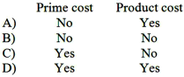  A. Option A  B. Option B  C. Option C  D. Option D

32. | The wages of factory maintenance personnel would usually be considered to be:  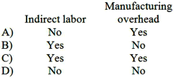  A. Option A  B. Option B  C. Option C  D. Option D

33. | Manufacturing overhead consists of:  A. all manufacturing costs.  B. indirect materials but not indirect labor.  C. all manufacturing costs, except direct materials and direct labor.  D. indirect labor but not indirect materials.

34. | Which of the following should NOT be included as part of manufacturing overhead at a company that makes office furniture?  A. sheet steel in a file cabinet made by the company.  B. manufacturing equipment depreciation.  C. idle time for direct labor.  D. taxes on a factory building.

35. | Which of the following costs would not be included as part of manufacturing overhead?  A. Insurance on sales vehicles.  B. Depreciation of production equipment.  C. Lubricants for production equipment.  D. Direct labor overtime premium.

36. | Conversion cost consists of which of the following?  A. Manufacturing overhead cost.  B. Direct materials and direct labor cost.  C. Direct labor cost.  D. Direct labor and manufacturing overhead cost.

37. | The advertising costs that Pepsi incurred to air its commercials during the Super Bowl can best be described as a:  A. variable cost.  B. fixed cost.  C. product cost.  D. prime cost.

38. | Each of the following would be a period cost except:  A. the salary of the company president's secretary.  B. the cost of a general accounting office.  C. depreciation of a machine used in manufacturing.  D. sales commissions.

39. | Which of the following costs is an example of a period rather than a product cost?  A. Depreciation on production equipment.  B. Wages of salespersons.  C. Wages of production machine operators.  D. Insurance on production equipment.

40. | Which of the following would be considered a product cost for external financial reporting purposes?  A. Cost of a warehouse used to store finished goods.  B. Cost of guided public tours through the company's facilities.  C. Cost of travel necessary to sell the manufactured product.  D. Cost of sand spread on the factory floor to absorb oil from manufacturing machines.

41. | Which of the following would NOT be treated as a product cost for external financial reporting purposes?  A. Depreciation on a factory building.  B. Salaries of factory workers.  C. Indirect labor in the factory.  D. Advertising expenses.

42. | The salary of the president of a manufacturing company would be classified as which of the following?  A. Product cost  B. Period cost  C. Manufacturing overhead  D. Direct labor

43. | Conversion costs do NOT include:  A. depreciation.  B. direct materials.  C. indirect labor.  D. indirect materials.

44. | Last month, when 10,000 units of a product were manufactured, the cost per unit was $60. At this level of activity, variable costs are 50% of total unit costs. If 10,500 units are manufactured next month and cost behavior patterns remain unchanged the:  A. total variable cost will remain unchanged.  B. fixed costs will increase in total.  C. variable cost per unit will increase.  D. total cost per unit will decrease.

45. | Variable cost:  A. increases on a per unit basis as the number of units produced increases.  B. remains constant on a per unit basis as the number of units produced increases.  C. remains the same in total as production increases.  D. decreases on a per unit basis as the number of units produced increases.

46. | Which of the following statements regarding fixed costs is incorrect?  A. Expressing fixed costs on a per unit basis usually is the best approach for decision making.  B. Fixed costs expressed on a per unit basis will decrease with increases in activity.  C. Total fixed costs are constant within the relevant range.  D. Fixed costs expressed on a per unit basis will increase with decreases in activity.

47. | The salary paid to the production manager in a factory is:  A. a variable cost.  B. part of prime cost.  C. part of conversion cost.  D. both a variable cost and a prime cost.

48. | Within the relevant range, variable cost per unit will:  A. increase as the level of activity increases.  B. remain constant.  C. decrease as the level of activity increases.  D. none of these.

49. | The term "relevant range" means the range of activity over which:  A. relevant costs are incurred.  B. costs may fluctuate.  C. production may vary.  D. the assumptions about fixed and variable cost behavior are reasonably valid.

50. | An example of a committed fixed cost is:  A. a training program for salespersons.  B. executive travel expenses.  C. property taxes on the factory building.  D. new product research and development.

51. | In describing the cost formula equation Y = a + bX, which of the following statements is correct?  A. "X" is the dependent variable.  B. "a" is the fixed component.  C. In the high-low method, "b" equals change in activity divided by change in costs.  D. As "X" increases "Y" decreases.

52. | Which one of the following costs should NOT be considered a direct cost of serving a particular customer who orders a customized personal computer by phone directly from the manufacturer?  A. the cost of the hard disk drive installed in the computer.  B. the cost of shipping the computer to the customer.  C. the cost of leasing a machine on a monthly basis that automatically tests hard disk drives before they are installed in computers.  D. the cost of packaging the computer for shipment.

53. | The term differential cost refers to:  A. a difference in cost which results from selecting one alternative instead of another.  B. the benefit forgone by selecting one alternative instead of another.  C. a cost which does not involve any dollar outlay but which is relevant to the decision-making process.  D. a cost which continues to be incurred even though there is no activity.

54. | Which of the following costs is often important in decision making, but is omitted from conventional accounting records?  A. Fixed cost.  B. Sunk cost.  C. Opportunity cost.  D. Indirect cost.

55. | When a decision is made among a number of alternatives, the benefit that is lost by choosing one alternative over another is the:  A. realized cost.  B. opportunity cost.  C. conversion cost.  D. accrued cost.

56. | The following costs were incurred in September:  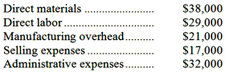  Conversion costs during the month totaled:  A. $50,000  B. $59,000  C. $137,000  D. $67,000

57. | The following costs were incurred in September:  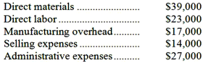  Prime costs during the month totaled:  A. $79,000  B. $120,000  C. $62,000  D. $40,000

58. | In September direct labor was 40% of conversion cost. If the manufacturing overhead for the month was $66,000 and the direct materials cost was $20,000, the direct labor cost was:  A. $13,333  B. $44,000  C. $99,000  D. $30,000

59. | Aberge Company's manufacturing overhead is 60% of its total conversion costs. If direct labor is $38,000 and if direct materials are $21,000, the manufacturing overhead is:  A. $57,000  B. $88,500  C. $25,333  D. $31,500

60. | During the month of September, direct labor cost totaled $11,000 and direct labor cost was 40% of prime cost. If total manufacturing costs during September were $73,000, the manufacturing overhead was:  A. $16,500  B. $27,500  C. $62,000  D. $45,500

61. | A manufacturing company prepays its insurance coverage for a three-year period. The premium for the three years is $2,700 and is paid at the beginning of the first year. Eighty percent of the premium applies to manufacturing operations and 20% applies to selling and administrative activities. What amounts should be considered product and period costs respectively for the first year of coverage?  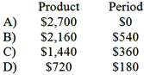  A. Option A  B. Option B  C. Option C  D. Option D

62. | Iadanza Corporation is a wholesaler that sells a single product. Management has provided the following cost data for two levels of monthly sales volume. The company sells the product for $195.70 per unit.  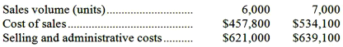  The best estimate of the total contribution margin when 6,300 units are sold is:  A. $752,220  B. $638,190  C. $100,170  D. $177,030

63. | Gambarini Corporation is a wholesaler that sells a single product. Management has provided the following cost data for two levels of monthly sales volume. The company sells the product for $197.80 per unit.  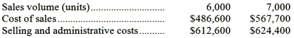  The best estimate of the total monthly fixed cost is:  A. $541,800  B. $1,192,100  C. $1,099,200  D. $1,145,650

64. | Bakker Corporation has provided the following production and average cost data for two levels of monthly production volume. The company produces a single product.  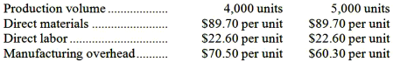  The best estimate of the total variable manufacturing cost per unit is:  A. $89.70  B. $131.80  C. $19.50  D. $112.30

65. | Carbaugh Corporation has provided the following production and average cost data for two levels of monthly production volume. The company produces a single product.  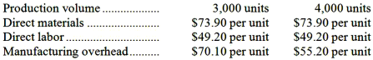  The best estimate of the total cost to manufacture 3,300 units is closest to:  A. $637,560  B. $612,975  C. $588,390  D. $619,680

66. | Edeen Corporation has provided the following production and total cost data for two levels of monthly production volume. The company produces a single product.  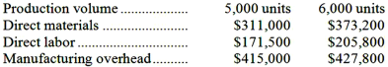  The best estimate of the total variable manufacturing cost per unit is:  A. $62.20  B. $96.50  C. $109.30  D. $12.80

67. | Dabney Corporation has provided the following production and total cost data for two levels of monthly production volume. The company produces a single product.  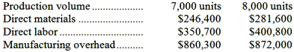  The best estimate of the total monthly fixed manufacturing cost is:  A. $778,400  B. $1,457,400  C. $1,505,900  D. $1,554,400

68. | Haras Corporation is a wholesaler that sells a single product. Management has provided the following cost data for two levels of monthly sales volume. The company sells the product for $141.30 per unit.  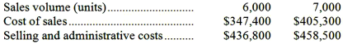  The best estimate of the total variable cost per unit is:  A. $123.40  B. $79.60  C. $57.90  D. $130.70

69. | Faraz Corporation has provided the following production and total cost data for two levels of monthly production volume. The company produces a single product.  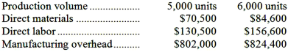  The best estimate of the total cost to manufacture 5,300 units is closest to:  A. $1,002,230  B. $1,021,780  C. $1,063,180  D. $941,280

70. | Anderwald Corporation has provided the following production and average cost data for two levels of monthly production volume. The company produces a single product.  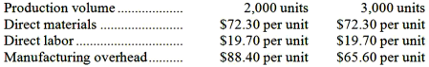  The best estimate of the total monthly fixed manufacturing cost is:  A. $360,800  B. $136,800  C. $196,800  D. $176,800

71. | Anaconda Mining Company shipped 9,000 tons of copper concentrate for $450,000 in March and 11,000 tons for $549,000 in April. Shipping costs for 12,000 tons to be shipped in May would be expected to be:  A. $548,780  B. $549,020  C. $594,000  D. $598,500

72. | Average maintenance costs are $1.50 per machine-hour at an activity level of 8,000 machine-hours and $1.20 per machine-hour at an activity level of 13,000 machine-hours. Assuming that this activity is within the relevant range, total expected maintenance cost for a budgeted activity level of 10,000 machine-hours would be closest to:  A. $16,128  B. $15,000  C. $13,440  D. $11,433

73. | The following data pertains to activity and the cost of cleaning and maintenance for two recent months:  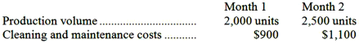  The best estimate of the total month 1 variable cost for cleaning and maintenance is:  A. $300  B. $500  C. $800  D. $100

74. | The following data pertains to activity and costs for two months:  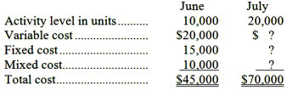  Assuming that these activity levels are within the relevant range, the mixed cost for July was:  A. $10,000  B. $35,000  C. $15,000  D. $40,000

75. | At an activity level of 9,200 machine-hours in a month, Nooner Corporation's total variable production engineering cost is $761,300 and its total fixed production engineering cost is $154,008. What would be the total production engineering cost per unit, both fixed and variable, at an activity level of 9,300 machine-hours in a month? Assume that this level of activity is within the relevant range.  A. $98.42  B. $99.49  C. $99.31  D. $98.96

76. | Jumpst Corporation uses the cost formula Y = $3,600 + $0.30X for the maintenance cost in Department B, where X is machine-hours. The August budget is based on 20,000 hours of planned machine time. Maintenance cost expected to be incurred during August is:  A. $3,600  B. $6,000  C. $6,300  D. $9,600

77. | Given the cost formula, Y = $9,000 + $2.50X, total cost for an activity level of 3,000 units would be:  A. $9,750  B. $12,000  C. $16,500  D. $7,500

78. | Blore Corporation reports that at an activity level of 7,300 units, its total variable cost is $511,803 and its total fixed cost is $76,650. What would be the total cost, both fixed and variable, at an activity level of 7,500 units? Assume that this level of activity is within the relevant range.  A. $604,575  B. $602,475  C. $596,514  D. $588,453

79. | Given the cost formula Y = $15,000 + $5X, total cost at an activity level of 8,000 units would be:  A. $23,000  B. $15,000  C. $55,000  D. $40,000

80. | At a volume of 10,000 units, Company P incurs $30,000 in factory overhead costs, including $10,000 in fixed costs. Assuming that this activity is within the relevant range, if volume increases to 12,000 units, Company P would expect to incur total factory overhead costs of:  A. $36,000  B. $34,000  C. $30,000  D. $32,000

81. | At an activity level of 4,400 units in a month, Goldbach Corporation's total variable maintenance and repair cost is $313,632 and its total fixed maintenance and repair cost is $93,104. What would be the total maintenance and repair cost, both fixed and variable, at an activity level of 4,600 units in a month? Assume that this level of activity is within the relevant range.  A. $420,992  B. $425,224  C. $415,980  D. $406,736

82. | Supply costs at Lattea Corporation's chain of gyms are listed below:  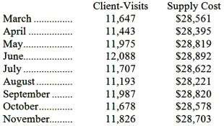  Management believes that supply cost is a mixed cost that depends on client-visits. Using the high-low method to estimate the variable and fixed components of this cost, those estimates would be closest to:  A. $2.44 per client-visit; $28,623 per month  B. $1.33 per client-visit; $12,768 per month  C. $0.79 per client-visit; $19,321 per month  D. $0.75 per client-visit; $19,826 per month

83. | Electrical costs at one of Vanartsdalen Corporation's factories are listed below:  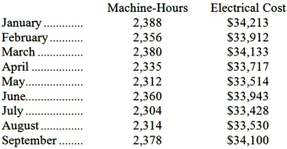  Management believes that electrical cost is a mixed cost that depends on machine-hours. Using the high-low method to estimate the variable and fixed components of this cost, these estimates would be closest to:  A. $14.41 per machine-hour; $33,832 per month  B. $0.11 per machine-hour; $33,957 per month  C. $9.35 per machine-hour; $11,885 per month  D. $11.30 per machine-hour; $7,229 per month

84. | A soft drink bottler incurred the following plant utility costs: 1,800 units bottled with utility costs of $5,750, and 1,500 units bottled with utility costs of $5,200. What is the variable cost per unit bottled (Use the High-low method. Round to the nearest cent.)  A. $3.47  B. $3.19  C. $1.83  D. None of these is true.

85. | The following data pertains to activity and maintenance costs for two recent years:  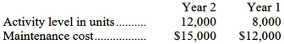  Using the high-low method, the cost formula for maintenance would be:  A. $1.50 per unit  B. $1.25 per unit  C. $3,000 plus $1.50 per unit  D. $6,000 plus $0.75 per unit

86. | The following data pertains to activity and utility costs for two recent years:  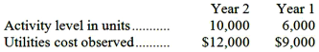  Using the high-low method, the cost formula for utilities is:  A. $1.50 per unit  B. $1.20 per unit  C. $3,000 plus $3.00 per unit  D. $4,500 plus $0.75 per unit

87. | Maintenance costs at a Tierce Corporation factory are listed below:  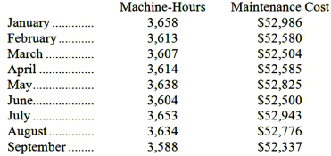  Management believes that maintenance cost is a mixed cost that depends on machine-hours. Using the high-low method to estimate the variable and fixed components of this cost, these estimates would be closest to:  A. $14.54 per machine-hour; $52,671 per month  B. $9.27 per machine-hour; $19,076 per month  C. $0.11 per machine-hour; $52,591 per month  D. $9.27 per machine-hour; $19,071 per month

88. | Buckeye Company has provided the following data for maintenance cost:  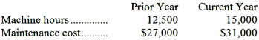  The best estimate of the cost formula for maintenance would be:  A. $21,625 per year plus $0.625 per machine hour  B. $7,000 per year plus $0.625 per machine hour  C. $7,000 per year plus $1.60 per machine hour  D. $27,000 per year plus $1.60 per machine hour

89. | Haar Inc. is a merchandising company. Last month the company's cost of goods sold was $61,000. The company's beginning merchandise inventory was $11,000 and its ending merchandise inventory was $21,000. What was the total amount of the company's merchandise purchases for the month?  A. $61,000  B. $51,000  C. $71,000  D. $93,000

90. | Gabruk Inc. is a merchandising company. Last month the company's merchandise purchases totaled $88,000. The company's beginning merchandise inventory was $15,000 and its ending merchandise inventory was $13,000. What was the company's cost of goods sold for the month?  A. $88,000  B. $90,000  C. $86,000  D. $116,000

A partial listing of costs incurred during December at Gagnier Corporation appears below:
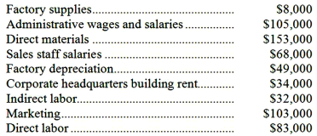

91. | The total of the period costs listed above for December is:  A. $89,000  B. $310,000  C. $325,000  D. $399,000

92. | The total of the manufacturing overhead costs listed above for December is:  A. $325,000  B. $635,000  C. $89,000  D. $40,000

93. | The total of the product costs listed above for December is:  A. $310,000  B. $89,000  C. $635,000  D. $325,000

A partial listing of costs incurred at Backes Corporation during November appears below:
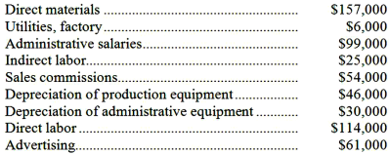

94. | The total of the manufacturing overhead costs listed above for November is:  A. $348,000  B. $31,000  C. $592,000  D. $77,000

95. | The total of the product costs listed above for November is:  A. $77,000  B. $348,000  C. $592,000  D. $244,000

96. | The total of the period costs listed above for November is:  A. $244,000  B. $321,000  C. $348,000  D. $77,000

Dickison Corporation reported the following data for the month of December:
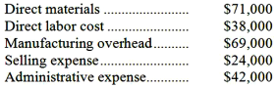

97. | The conversion cost for December was:  A. $107,000  B. $142,000  C. $111,000  D. $178,000

98. | The prime cost for December was:  A. $109,000  B. $111,000  C. $107,000  D. $66,000

Management of Mcentire Corporation has asked your help as an intern in preparing some key reports for April. Direct materials cost was $64,000, direct labor cost was $47,000, and manufacturing overhead was $75,000. Selling expense was $15,000 and administrative expense was $44,000.

99. | The conversion cost for April was:  A. $186,000  B. $100,000  C. $128,000  D. $122,000

100. | The prime cost for April was:  A. $59,000  B. $122,000  C. $100,000  D. $111,000

Callander Corporation is a wholesaler that sells a single product. Management has provided the following cost data for two levels of monthly sales volume. The company sells the product for $151.60 per unit.
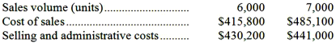

101. | The best estimate of the total monthly fixed cost is:  A. $846,000  B. $886,050  C. $365,400  D. $926,100

102. | The best estimate of the total variable cost per unit is:  A. $141.00  B. $80.10  C. $69.30  D. $132.30

103. | The best estimate of the total contribution margin when 6,300 units are sold is:  A. $450,450  B. $518,490  C. $121,590  D. $66,780

Babuca Corporation has provided the following production and total cost data for two levels of monthly production volume. The company produces a single product.
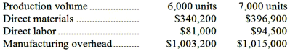

104. | The best estimate of the total monthly fixed manufacturing cost is:  A. $1,424,400  B. $1,506,400  C. $932,400  D. $1,465,400

105. | The best estimate of the total variable manufacturing cost per unit is:  A. $82.00  B. $70.20  C. $56.70  D. $11.80

106. | The best estimate of the total cost to manufacture 6,300 units is closest to:  A. $1,425,690  B. $1,355,760  C. $1,495,620  D. $1,449,000

The following production and average cost data for two levels of monthly production volume have been supplied by a company that produces a single product:
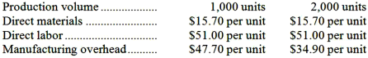

107. | The best estimate of the total monthly fixed manufacturing cost is:  A. $25,600  B. $114,400  C. $47,700  D. $69,800

108. | The best estimate of the total variable manufacturing cost per unit is:  A. $22.10  B. $66.70  C. $88.80  D. $15.70

109. | The best estimate of the total cost to manufacture 1,200 units is closest to:  A. $132,160  B. $121,920  C. $129,600  D. $137,280

Erkkila Inc. reports that at an activity level of 7,900 machine-hours in a month, its total variable inspection cost is $210,061 and its total fixed inspection cost is $191,970.

110. | What would be the average fixed inspection cost per unit at an activity level of 8,100 machine-hours in a month? Assume that this level of activity is within the relevant range.  A. $50.89  B. $24.30  C. $23.70  D. $32.96

111. | What would be the total variable inspection cost at an activity level of 8,100 machine-hours in a month? Assume that this level of activity is within the relevant range.  A. $210,061  B. $196,830  C. $215,379  D. $402,031

At an activity level of 5,300 machine-hours in a month, Clyburn Corporation's total variable maintenance cost is $114,268 and its total fixed maintenance cost is $154,336.

112. | What would be the total variable maintenance cost at an activity level of 5,600 machine-hours in a month? Assume that this level of activity is within the relevant range.  A. $163,072  B. $268,604  C. $114,268  D. $120,736

113. | What would be the average fixed maintenance cost per unit at an activity level of 5,600 machine-hours in a month? Assume that this level of activity is within the relevant range.  A. $50.68  B. $27.56  C. $35.79  D. $29.12

Slappy Corporation leases its corporate headquarters building. This lease cost is fixed with respect to the company's sales volume. In a recent month in which the sales volume was 20,000 units, the lease cost was $482,000.

114. | To the nearest whole dollar, what should be the total lease cost at a sales volume of 16,900 units in a month? (Assume that this sales volume is within the relevant range.)  A. $407,290  B. $482,000  C. $570,414  D. $444,645

115. | To the nearest whole cent, what should be the average lease cost per unit at a sales volume of 19,200 units in a month? (Assume that this sales volume is within the relevant range.)  A. $28.52  B. $24.60  C. $25.10  D. $24.10

At a sales volume of 35,000 units, Thoma Corporation's sales commissions (a cost that is variable with respect to sales volume) total $448,000.

116. | To the nearest whole dollar, what should be the total sales commissions at a sales volume of 33,200 units? (Assume that this sales volume is within the relevant range.)  A. $424,960  B. $448,000  C. $436,480  D. $472,289

117. | To the nearest whole cent, what should be the average sales commission per unit at a sales volume of 36,800 units? (Assume that this sales volume is within the relevant range.)  A. $13.49  B. $12.17  C. $12.80  D. $12.49

At a sales volume of 27,000 units, Danielle Corporation's property taxes (a cost that is fixed with respect to sales volume) total $207,900.

118. | To the nearest whole dollar, what should be the total property taxes at a sales volume of 30,900 units? (Assume that this sales volume is within the relevant range.)  A. $207,900  B. $181,660  C. $222,915  D. $237,930

119. | To the nearest whole cent, what should be the average property tax per unit at a sales volume of 27,600 units? (Assume that this sales volume is within the relevant range.)  A. $6.73  B. $7.70  C. $7.62  D. $7.53

Chaffee Corporation staffs a helpline to answer questions from customers. The costs of operating the helpline are variable with respect to the number of calls in a month. At a volume of 33,000 calls in a month, the costs of operating the helpline total $742,500.

120. | To the nearest whole dollar, what should be the total cost of operating the helpline costs at a volume of 34,800 calls in a month? (Assume that this call volume is within the relevant range.)  A. $742,500  B. $783,000  C. $704,095  D. $762,750

121. | To the nearest whole cent, what should be the average cost of operating the helpline per call at a volume of 36,100 calls in a month? (Assume that this call volume is within the relevant range.)  A. $21.54  B. $20.57  C. $21.34  D. $22.50

Emilio Corporation reports that at an activity level of 3,400 units, its total variable cost is $59,058 and its total fixed cost is $101,150.

122. | What would be the total variable cost at an activity level of 3,500 units? Assume that this level of activity is within the relevant range.  A. $59,058  B. $160,208  C. $60,795  D. $104,125

123. | What would be the average fixed cost per unit at an activity level of 3,500 units? Assume that this level of activity is within the relevant range.  A. $29.75  B. $47.12  C. $35.26  D. $28.90

Inspection costs at one of Krivanek Corporation's factories are listed below:
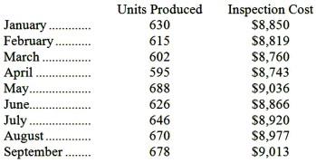
Management believes that inspection cost is a mixed cost that depends on units produced.

124. | Using the high-low method, the estimate of the variable component of inspection cost per unit produced is closest to:  A. $3.15  B. $0.32  C. $3.40  D. $13.91

125. | Using the high-low method, the estimate of the fixed component of inspection cost per month is closest to:  A. $8,743  B. $8,887  C. $8,683  D. $6,869

Glatt Inc., an escrow agent, has provided the following data concerning its office expenses:
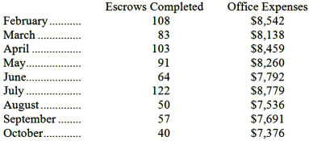
Management believes that office expense is a mixed cost that depends on the number of escrows completed. Note: Real estate purchases usually involve the services of an escrow agent that holds funds and prepares documents to complete the transaction.

126. | Using the high-low method, the estimate of the variable component of office expense per escrow completed is closest to:  A. $101.08  B. $59.12  C. $17.11  D. $17.15

127. | Using the high-low method, the estimate of the fixed component of office expense per month is closest to:  A. $6,692  B. $8,064  C. $7,376  D. $7,720

Electrical costs at one of Reifel Corporation's factories are listed below:
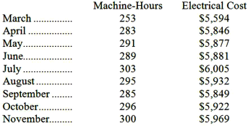
Management believes that electrical cost is a mixed cost that depends on machine-hours.

128. | Using the high-low method, the estimate of the variable component of electrical cost per machine-hour is closest to:  A. $0.12  B. $20.38  C. $7.98  D. $8.22

129. | Using the high-low method, the estimate of the fixed component of electrical cost per month is closest to:  A. $5,594  B. $3,514  C. $5,875  D. $5,840

The following data have been provided by a retailer that sells a single product.
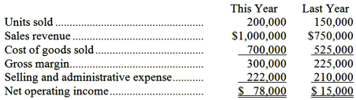

130. | What is the best estimate of the company's variable selling and administrative expense per unit?  A. $4.17 per unit  B. $0.24 per unit  C. $0.90 per unit  D. $0.71 per unit

131. | What is the best estimate of the company's total fixed selling and administrative expense per year?  A. $0  B. $80,000  C. $44,000  D. 174,000

132. | What is the best estimate of the company's contribution margin for this year?  A. $252,000  B. $300,000  C. $158,000  D. $120,000

Nikkel Corporation, a merchandising company, reported the following results for July:
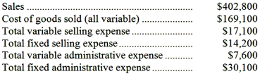

133. | The gross margin for July is:  A. $358,500  B. $209,000  C. $233,700  D. $164,700

134. | The contribution margin for July is:  A. $333,800  B. $209,000  C. $233,700  D. $164,700

Holzhauer Corporation, a merchandising company, reported the following results for March:
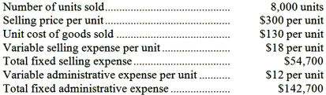
Cost of goods sold is a variable cost in this company.

135. | The gross margin for March is:  A. $922,600  B. $1,120,000  C. $2,202,600  D. $1,360,000

136. | The contribution margin for March is:  A. $922,600  B. $1,120,000  C. $1,962,600  D. $1,360,000

Fiene Sales, Inc., a merchandising company, reported sales of 2,200 units in June at a selling price of $600 per unit. Cost of goods sold, which is a variable cost, was $364 per unit. Variable selling expenses were $23 per unit and variable administrative expenses were $33 per unit. The total fixed selling expenses were $30,500 and the total administrative expenses were $55,300.

137. | The contribution margin for June was:  A. $1,111,000  B. $396,000  C. $310,200  D. $519,200

138. | The gross margin for June was:  A. $310,200  B. $1,234,200  C. $396,000  D. $519,200

Getchman Marketing, Inc., a merchandising company, reported sales of $592,500 and cost of goods sold of $305,000 for April. The company's total variable selling expense was $37,500; its total fixed selling expense was $16,000; its total variable administrative expense was $35,000; and its total fixed administrative expense was $38,900. The cost of goods sold in this company is a variable cost.

139. | The contribution margin for April is:  A. $465,100  B. $287,500  C. $160,100  D. $215,000

140. | The gross margin for April is:  A. $287,500  B. $215,000  C. $537,600  D. $160,100

Salvadore Inc., a local retailer, has provided the following data for the month of September:
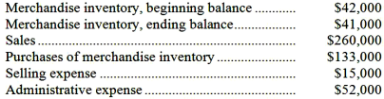

141. | The cost of goods sold for September was:  A. $132,000  B. $134,000  C. $133,000  D. $200,000

142. | The net operating income for September was:  A. $60,000  B. $128,000  C. $127,000  D. $59,000

The following cost data pertain to the operations of Swestka Department Stores, Inc., for the month of July.
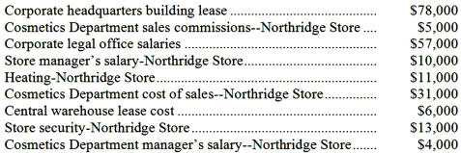
The Northridge Store is just one of many stores owned and operated by the company. The Cosmetics Department is one of many departments at the Northridge Store. The central warehouse serves all of the company's stores.

143. | What is the total amount of the costs listed above that are direct costs of the Cosmetics Department?  A. $74,000  B. $36,000  C. $31,000  D. $40,000

144. | What is the total amount of the costs listed above that are NOT direct costs of the Northridge Store?  A. $40,000  B. $34,000  C. $141,000  D. $78,000

The following cost data pertain to the operations of Mancia Department Stores, Inc., for the month of February.
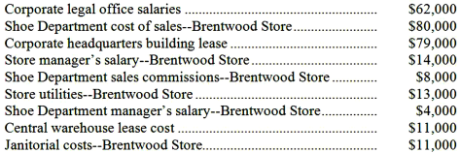
The Brentwood Store is just one of many stores owned and operated by the company. The Shoe Department is one of many departments at the Brentwood Store. The central warehouse serves all of the company's stores.

145. | What is the total amount of the costs listed above that are direct costs of the Shoe Department?  A. $80,000  B. $88,000  C. $130,000  D. $92,000

146. | What is the total amount of the costs listed above that are NOT direct costs of the Brentwood Store?  A. $152,000  B. $92,000  C. $79,000  D. $38,000

Management of Modugno Corporation is considering whether to purchase a new model 370 machine costing $441,000 or a new model 240 machine costing $387,000 to replace a machine that was purchased 7 years ago for $429,000. The old machine was used to make product M25A until it broke down last week. Unfortunately, the old machine cannot be repaired.
Management has decided to buy the new model 240 machine. It has less capacity than the new model 370 machine, but its capacity is sufficient to continue making product M25A.
Management also considered, but rejected, the alternative of simply dropping product M25A. If that were done, instead of investing $387,000 in the new machine, the money could be invested in a project that would return a total of $430,000.

147. | In making the decision to buy the model 240 machine rather than the model 370 machine, the sunk cost was:  A. $430,000  B. $429,000  C. $387,000  D. $441,000

148. | In making the decision to buy the model 240 machine rather than the model 370 machine, the differential cost was:  A. $12,000  B. $1,000  C. $54,000  D. $42,000

149. | In making the decision to invest in the model 240 machine, the opportunity cost was:  A. $430,000  B. $441,000  C. $387,000  D. $429,000

Temblador Corporation purchased a machine 7 years ago for $319,000 when it launched product E26T. Unfortunately, this machine has broken down and cannot be repaired. The machine could be replaced by a new model 330 machine costing $323,000 or by a new model 230 machine costing $285,000. Management has decided to buy the model 230 machine. It has less capacity than the model 330 machine, but its capacity is sufficient to continue making product E26T. Management also considered, but rejected, the alternative of dropping product E26T and not replacing the old machine. If that were done, the $285,000 invested in the new machine could instead have been invested in a project that would have returned a total of $386,000.

150. | In making the decision to buy the model 230 machine rather than the model 330 machine, the differential cost was:  A. $34,000  B. $38,000  C. $4,000  D. $67,000

151. | In making the decision to buy the model 230 machine rather than the model 330 machine, the sunk cost was:  A. $319,000  B. $386,000  C. $285,000  D. $323,000

152. | In making the decision to invest in the model 230 machine, the opportunity cost was:  A. $386,000  B. $319,000  C. $285,000  D. $323,000

Essay Questions
153. | Bill Pope has developed a new device that is so exciting he is considering quitting his job in order to produce and market it on a large-scale basis. Bill will rent a garage for $300 per month for production purposes. Utilities will cost $40 per month. Bill has already taken an industrial design course at the local community college to help prepare for this venture. The course cost $300. Bill will rent production equipment at a monthly cost of $800. He estimates the material cost per unit will be $5, and the labor cost will be $3. He will hire workers and spend his time promoting the product. To do this he will quit his job which pays $3,000 per month. Advertising and promotion will cost $900 per month.  Required:  Complete the chart below by placing an "X" under each heading that helps to identify the cost involved. There can be "Xs" placed under more than one heading for a single cost, e.g., a cost might be a sunk cost, an overhead cost and a product cost; there would be an "X" placed under each of these headings opposite the cost.  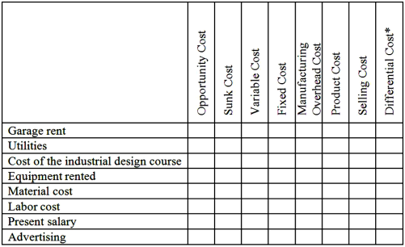  * Between the alternatives of going into business to make the device or not going into business to make the device.

154. | Laco Company acquired its factory building about 20 years ago. For a number of years the company has rented out a small, unused part of the building. The renter's lease will expire soon. Rather than renewing the lease, Laco Company is considering using the space itself to manufacture a new product. Under this option, the unused space will continue to be depreciated on a straight-line basis, as in past years.  Direct materials and direct labor cost for the new product would be $50 per unit. In order to have a place to store finished units of the new product, the company would have to rent a small warehouse nearby. The rental cost would be $2,000 per month. It would cost the company an additional $4,000 each month to advertise the new product. A new production supervisor would be hired to oversee production of the new product who would be paid $3,000 per month. The company would pay a sales commission of $10 for each unit of product that is sold.  Required:  Complete the chart below by placing an "X" under each column heading that helps to identify the costs listed to the left. There can be "X's" placed under more than one heading for a single cost. For example, a cost might be a product cost, an opportunity cost, and a sunk cost; there would be an "X" placed under each of these headings on the answer sheet opposite the cost.  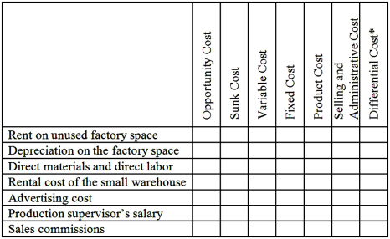  *Between the alternatives of (1) renting the space out again or (2) using the space to produce the new product.

155. | Lettman Corporation has provided the following partial listing of costs incurred during November:  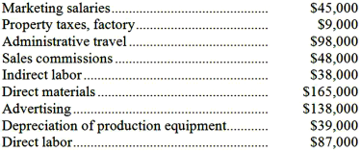  Required:  a. What is the total amount of product cost listed above? Show your work.  b. What is the total amount of period cost listed above? Show your work.

156. | A partial listing of costs incurred at Starr Corporation during June appears below:  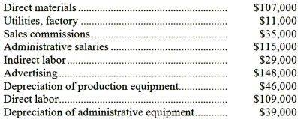  Required:  a. What is the total amount of product cost listed above? Show your work.  b. What is the total amount of period cost listed above? Show your work.

157. | The following information summarizes the company's cost structure:  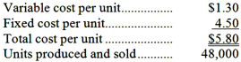  Required:  Estimate the following costs at the 40,000 unit level of activity:  a. Total variable cost.  b. Total fixed cost.  c. Variable cost per unit.  d. Fixed cost per unit.

158. | Corio Corporation reports that at an activity level of 3,800 units, its total variable cost is $221,464 and its total fixed cost is $94,848.  Required:  For the activity level of 3,900 units, compute: (a) the total variable cost; (b) the total fixed cost; (c) the total cost; (d) the average variable cost per unit; (e) the average fixed cost per unit; and (f) the average total cost per unit. Assume that this activity level is within the relevant range.

159. | At an activity level of 5,900 units, Haas Corporation's total variable cost is $347,982 and its total fixed cost is $284,321.  Required:  For the activity level of 6,100 units, compute: (a) the total variable cost; (b) the total fixed cost; (c) the total cost; (d) the average variable cost per unit; (e) the average fixed cost per unit; and (f) the average total cost per unit. Assume that this activity level is within the relevant range.

160. | A number of costs and measures of activity are listed below.  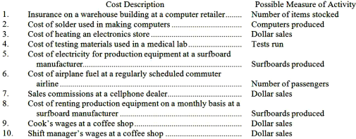  Required:  For each item above, indicate whether the cost is MAINLY fixed or variable with respect to the possible measure of activity listed next to it.

161. | A number of costs and measures of activity are listed below.  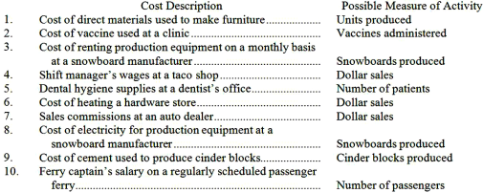  Required:  For each item above, indicate whether the cost is MAINLY fixed or variable with respect to the possible measure of activity listed next to it.

162. | Slonaker Inc. has provided the following data concerning its maintenance costs:  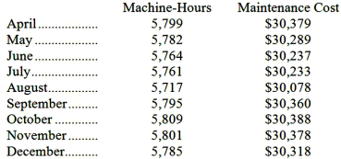  Management believes that maintenance cost is a mixed cost that depends on machine-hours.  Required:  Estimate the variable cost per machine-hour and the fixed cost per month using the high-low method. Show your work!

163. | Utility costs at one of Helker Corporation's factories are listed below:  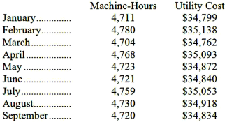  Management believes that utility cost is a mixed cost that depends on machine-hours.  Required:  Estimate the variable cost per machine-hour and the fixed cost per month using the high-low method. Show your work! Round off all calculations to the nearest whole cent.

164. | The management of Harrigill Corporation would like to have a better understanding of the behavior of its inspection costs. The company has provided the following data:  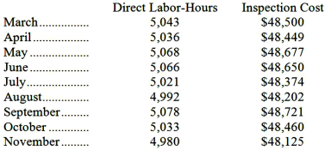  Management believes that inspection cost is a mixed cost that depends on direct labor-hours.  Required:  Estimate the variable cost per direct labor-hour and the fixed cost per month using the high-low method. Show your work! Round off all calculations to the nearest whole cent.

165. | In October, Patnode Inc., a merchandising company, had sales of $294,000, selling expenses of $27,000, and administrative expenses of $35,000. The cost of merchandise purchased during the month was $211,000. The beginning balance in the merchandise inventory account was $38,000 and the ending balance was $34,000.  Required:  Prepare a traditional format income statement for October.

166. | Whitman Corporation, a merchandising company, reported sales of 7,400 units for May at a selling price of $677 per unit. The cost of goods sold (all variable) was $441 per unit and the variable selling expense was $54 per unit. The total fixed selling expense was $155,600. The variable administrative expense was $24 per unit and the total fixed administrative expense was $370,400.  Required:  a. Prepare a contribution format income statement for May.  b. Prepare a traditional format income statement for May.

167. | Donmoyer Sales Corporation, a merchandising company, reported total sales of $2,230,200 for May. The cost of goods sold (all variable) was $1,518,300, the total variable selling expense was $214,200, the total fixed selling expense was $86,700, the total variable administrative expense was $119,700, and the total fixed administrative expense was $138,400.  Required:  a. Prepare a contribution format income statement for May.  b. Prepare a traditional format income statement for May.

168. | Pittman Corporation, a merchandising company, reported the following results for September:  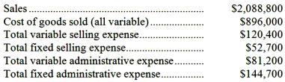  Required:  a. Prepare a traditional format income statement for September.  b. Prepare a contribution format income statement for September.

169. | Honey Corporation, a merchandising company, reported the following results for January:  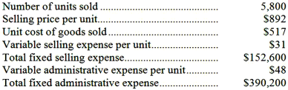  Cost of goods sold is a variable cost in this company.  Required:  a. Prepare a traditional format income statement for January.  b. Prepare a contribution format income statement for January.

170. | A number of costs are listed below.  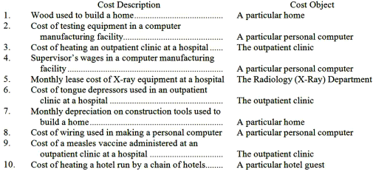  Required:  For each item above, indicate whether the cost is direct or indirect with respect to the cost object listed next to it.

Chapter 02 Managerial Accounting and Cost Concepts Answer Key

True / False Questions
1. | Direct material costs are generally variable costs.  TRUE

AACSB: Reflective Thinking
AICPA BB: Critical Thinking
AICPA FN: Measurement
Blooms: Remember
Learning Objective: 02-01 Identify and give examples of each of the three basic manufacturing cost categories.
Learning Objective: 02-03 Understand cost behavior patterns including variable costs; fixed costs; and mixed costs.
Level: 1 Easy

2. | Property taxes and insurance premiums paid on a factory building are examples of manufacturing overhead.  TRUE

AACSB: Reflective Thinking
AICPA BB: Critical Thinking
AICPA FN: Measurement
Blooms: Remember
Learning Objective: 02-01 Identify and give examples of each of the three basic manufacturing cost categories.
Level: 1 Easy

3. | Manufacturing overhead combined with direct materials is known as conversion cost.  FALSE

AACSB: Reflective Thinking
AICPA BB: Critical Thinking
AICPA FN: Measurement
Blooms: Remember
Learning Objective: 02-01 Identify and give examples of each of the three basic manufacturing cost categories.
Level: 1 Easy

4. | All costs incurred in a merchandising firm are considered to be period costs.  FALSE

AACSB: Reflective Thinking
AICPA BB: Critical Thinking
AICPA FN: Measurement
Blooms: Remember
Learning Objective: 02-02 Distinguish between product cost and period costs and give examples of each.
Level: 1 Easy

5. | Depreciation is always considered a product cost for external financial reporting purposes in a manufacturing firm.  FALSE

AACSB: Reflective Thinking
AICPA BB: Critical Thinking
AICPA FN: Measurement
Blooms: Understand
Learning Objective: 02-02 Distinguish between product cost and period costs and give examples of each.
Level: 2 Medium

6. | In external financial reports, factory utilities costs may be included in an asset account on the balance sheet at the end of the period.  TRUE

AACSB: Reflective Thinking
AICPA BB: Critical Thinking
AICPA FN: Measurement
Blooms: Understand
Learning Objective: 02-02 Distinguish between product cost and period costs and give examples of each.
Level: 3 Hard

7. | Advertising costs are considered product costs for external financial reports because they are incurred in order to promote specific products.  FALSE

AACSB: Reflective Thinking
AICPA BB: Critical Thinking
AICPA FN: Measurement
Blooms: Understand
Learning Objective: 02-02 Distinguish between product cost and period costs and give examples of each.
Level: 2 Medium

8. | Selling and administrative expenses are product costs under generally accepted accounting principles.  FALSE

AACSB: Reflective Thinking
AICPA BB: Critical Thinking
AICPA FN: Measurement
Blooms: Remember
Learning Objective: 02-02 Distinguish between product cost and period costs and give examples of each.
Level: 1 Easy

9. | A variable cost is a cost whose cost per unit varies as the activity level rises and falls.  FALSE

AACSB: Reflective Thinking
AICPA BB: Critical Thinking
AICPA FN: Measurement
Blooms: Remember
Learning Objective: 02-03 Understand cost behavior patterns including variable costs; fixed costs; and mixed costs.
Level: 1 Easy

10. | When the level of activity increases, total variable cost will increase.  TRUE

AACSB: Reflective Thinking
AICPA BB: Critical Thinking
AICPA FN: Measurement
Blooms: Remember
Learning Objective: 02-03 Understand cost behavior patterns including variable costs; fixed costs; and mixed costs.
Level: 1 Easy

11. | A decrease in production will ordinarily result in an increase in fixed production costs per unit.  TRUE

AACSB: Analytic
AICPA BB: Critical Thinking
AICPA FN: Measurement
Blooms: Remember
Learning Objective: 02-03 Understand cost behavior patterns including variable costs; fixed costs; and mixed costs.
Level: 1 Easy

12. | Automation results in a shift away from variable costs toward more fixed costs.  TRUE

AACSB: Reflective Thinking
AICPA BB: Critical Thinking
AICPA FN: Measurement
Blooms: Remember
Learning Objective: 02-03 Understand cost behavior patterns including variable costs; fixed costs; and mixed costs.
Level: 1 Easy

13. | In order for a cost to be variable it must vary with either units produced or units sold.  FALSE

AACSB: Reflective Thinking
AICPA BB: Critical Thinking
AICPA FN: Measurement
Blooms: Understand
Learning Objective: 02-03 Understand cost behavior patterns including variable costs; fixed costs; and mixed costs.
Level: 2 Medium

14. | The concept of the relevant range does not apply to fixed costs.  FALSE

AACSB: Reflective Thinking
AICPA BB: Critical Thinking
AICPA FN: Measurement
Blooms: Remember
Learning Objective: 02-03 Understand cost behavior patterns including variable costs; fixed costs; and mixed costs.
Level: 1 Easy

15. | Indirect costs, such as manufacturing overhead, are always fixed costs.  FALSE

AACSB: Reflective Thinking
AICPA BB: Critical Thinking
AICPA FN: Measurement
Blooms: Understand
Learning Objective: 02-03 Understand cost behavior patterns including variable costs; fixed costs; and mixed costs.
Level: 2 Medium

16. | Discretionary fixed costs arise from annual decisions by management to spend in certain fixed cost areas.  TRUE

AACSB: Reflective Thinking
AICPA BB: Critical Thinking
AICPA FN: Measurement
Blooms: Remember
Learning Objective: 02-03 Understand cost behavior patterns including variable costs; fixed costs; and mixed costs.
Level: 1 Easy

17. | Even if operations are interrupted or cut back, committed fixed costs remain largely unchanged in the short term because the costs of restoring them later are likely to be far greater than any short-run savings that might be realized.  TRUE

AACSB: Reflective Thinking
AICPA BB: Critical Thinking
AICPA FN: Measurement
Blooms: Remember
Learning Objective: 02-03 Understand cost behavior patterns including variable costs; fixed costs; and mixed costs.
Level: 1 Easy

18. | Committed fixed costs are fixed costs that are not controllable.  FALSE

AACSB: Reflective Thinking
AICPA BB: Critical Thinking
AICPA FN: Measurement
Blooms: Understand
Learning Objective: 02-03 Understand cost behavior patterns including variable costs; fixed costs; and mixed costs.
Level: 3 Hard

19. | A mixed cost is partially variable and partially fixed.  TRUE

AACSB: Reflective Thinking
AICPA BB: Critical Thinking
AICPA FN: Measurement
Blooms: Remember
Learning Objective: 02-03 Understand cost behavior patterns including variable costs; fixed costs; and mixed costs.
Level: 1 Easy

20. | Traditional format income statements are prepared primarily for external reporting purposes.  TRUE

AACSB: Reflective Thinking
AICPA BB: Critical Thinking
AICPA FN: Measurement
Blooms: Remember
Learning Objective: 02-05 Prepare income statements for a merchandising company using the traditional and contribution formats.
Level: 1 Easy

21. | In a contribution format income statement, sales minus cost of goods sold equals the gross margin.  FALSE

AACSB: Reflective Thinking
AICPA BB: Critical Thinking
AICPA FN: Measurement
Blooms: Remember
Learning Objective: 02-05 Prepare income statements for a merchandising company using the traditional and contribution formats.
Level: 1 Easy

22. | In a traditional format income statement for a merchandising company, the cost of goods sold reports the product costs attached to the merchandise sold during the period.  TRUE

AACSB: Reflective Thinking
AICPA BB: Critical Thinking
AICPA FN: Measurement
Blooms: Remember
Learning Objective: 02-05 Prepare income statements for a merchandising company using the traditional and contribution formats.
Level: 1 Easy

23. | Although the contribution format income statement is useful for external reporting purposes, it has serious limitations when used for internal purposes because it does not distinguish between fixed and variable costs.  FALSE

AACSB: Reflective Thinking
AICPA BB: Critical Thinking
AICPA FN: Measurement
Blooms: Remember
Learning Objective: 02-05 Prepare income statements for a merchandising company using the traditional and contribution formats.
Level: 1 Easy

24. | In a contribution format income statement for a merchandising company, cost of goods sold is a variable cost that gets included in the "Variable expenses" portion of the income statement.  TRUE

AACSB: Reflective Thinking
AICPA BB: Critical Thinking
AICPA FN: Measurement
Blooms: Remember
Learning Objective: 02-05 Prepare income statements for a merchandising company using the traditional and contribution formats.
Level: 1 Easy

25. | The traditional format income statement is used as an internal planning and decision-making tool. Its emphasis on cost behavior aids cost-volume-profit analysis, management performance appraisals, and budgeting.  FALSE

AACSB: Reflective Thinking
AICPA BB: Critical Thinking
AICPA FN: Measurement
Blooms: Remember
Learning Objective: 02-05 Prepare income statements for a merchandising company using the traditional and contribution formats.
Level: 1 Easy

26. | The following would typically be considered indirect costs of manufacturing a particular Boeing 747 to be delivered to Singapore Airlines: electricity to run production equipment, the factory manager's salary, and the cost of the General Electric jet engines installed on the aircraft.  FALSE

AACSB: Reflective Thinking
AICPA BB: Critical Thinking
AICPA FN: Measurement
Blooms: Remember
Learning Objective: 02-06 Understand the differences between direct and indirect costs.
Level: 2 Medium

27. | The following costs should be considered direct costs of providing delivery room services to a particular mother and her baby: the costs of drugs administered in the operating room, the attending physician's fees, and a portion of the liability insurance carried by the hospital to cover the delivery room.  FALSE

AACSB: Reflective Thinking
AICPA BB: Critical Thinking
AICPA FN: Measurement
Blooms: Understand
Learning Objective: 02-06 Understand the differences between direct and indirect costs.
Level: 3 Hard

28. | The following costs should be considered by a law firm to be indirect costs of defending a particular client in court: rent on the law firm's offices, the law firm's receptionist's wages, the costs of heating the law firm's offices, and the depreciation on the personal computer in the office of the attorney who has been assigned the client.  TRUE

AACSB: Reflective Thinking
AICPA BB: Critical Thinking
AICPA FN: Measurement
Blooms: Understand
Learning Objective: 02-06 Understand the differences between direct and indirect costs.
Level: 3 Hard

29. | In any decision making situation, sunk costs are irrelevant and should be ignored.  TRUE

AACSB: Reflective Thinking
AICPA BB: Critical Thinking
AICPA FN: Decision Making
Blooms: Remember
Learning Objective: 02-07 Understand cost classifications used in making decisions: differential costs; opportunity costs; and sunk costs.
Level: 1 Easy

Multiple Choice Questions
30. | For a lamp manufacturing company, the cost of the insurance on its vehicles that deliver lamps to customers is best described as a:  A. prime cost.  B. manufacturing overhead cost.  C. period cost.  D. differential (incremental) cost of a lamp.

AACSB: Reflective Thinking
AICPA BB: Critical Thinking
AICPA FN: Measurement
Blooms: Understand
Learning Objective: 02-01 Identify and give examples of each of the three basic manufacturing cost categories.
Learning Objective: 02-02 Distinguish between product cost and period costs and give examples of each.
Learning Objective: 02-07 Understand cost classifications used in making decisions: differential costs; opportunity costs; and sunk costs.
Level: 3 Hard

31. | The cost of leasing production equipment is classified as:  A. Option A  B. Option B  C. Option C  D. Option D

AACSB: Reflective Thinking
AICPA BB: Critical Thinking
AICPA FN: Measurement
Blooms: Understand
Learning Objective: 02-01 Identify and give examples of each of the three basic manufacturing cost categories.
Learning Objective: 02-02 Distinguish between product cost and period costs and give examples of each.
Level: 2 Medium

32. | The wages of factory maintenance personnel would usually be considered to be:  A. Option A  B. Option B  C. Option C  D. Option D

AACSB: Reflective Thinking
AICPA BB: Critical Thinking
AICPA FN: Measurement
Blooms: Understand
Learning Objective: 02-01 Identify and give examples of each of the three basic manufacturing cost categories.
Learning Objective: 02-06 Understand the differences between direct and indirect costs.
Level: 2 Medium

33. | Manufacturing overhead consists of:  A. all manufacturing costs.  B. indirect materials but not indirect labor.  C. all manufacturing costs, except direct materials and direct labor.  D. indirect labor but not indirect materials.

AACSB: Reflective Thinking
AICPA BB: Critical Thinking
AICPA FN: Measurement
Blooms: Understand
Learning Objective: 02-01 Identify and give examples of each of the three basic manufacturing cost categories.
Level: 2 Medium

34. | Which of the following should NOT be included as part of manufacturing overhead at a company that makes office furniture?  A. sheet steel in a file cabinet made by the company.  B. manufacturing equipment depreciation.  C. idle time for direct labor.  D. taxes on a factory building.

AACSB: Reflective Thinking
AICPA BB: Critical Thinking
AICPA FN: Measurement
Blooms: Understand
Learning Objective: 02-01 Identify and give examples of each of the three basic manufacturing cost categories.
Level: 2 Medium

35. | Which of the following costs would not be included as part of manufacturing overhead?  A. Insurance on sales vehicles.  B. Depreciation of production equipment.  C. Lubricants for production equipment.  D. Direct labor overtime premium.

AACSB: Reflective Thinking
AICPA BB: Critical Thinking
AICPA FN: Measurement
Blooms: Remember
Learning Objective: 02-01 Identify and give examples of each of the three basic manufacturing cost categories.
Level: 1 Easy

36. | Conversion cost consists of which of the following?  A. Manufacturing overhead cost.  B. Direct materials and direct labor cost.  C. Direct labor cost.  D. Direct labor and manufacturing overhead cost.

AACSB: Reflective Thinking
AICPA BB: Critical Thinking
AICPA FN: Measurement
Blooms: Remember
Learning Objective: 02-01 Identify and give examples of each of the three basic manufacturing cost categories.
Level: 1 Easy

37. | The advertising costs that Pepsi incurred to air its commercials during the Super Bowl can best be described as a:  A. variable cost.  B. fixed cost.  C. product cost.  D. prime cost.

AACSB: Reflective Thinking
AICPA BB: Critical Thinking
AICPA FN: Measurement
Blooms: Understand
Learning Objective: 02-02 Distinguish between product cost and period costs and give examples of each.
Learning Objective: 02-03 Understand cost behavior patterns including variable costs; fixed costs; and mixed costs.
Level: 2 Medium

38. | Each of the following would be a period cost except:  A. the salary of the company president's secretary.  B. the cost of a general accounting office.  C. depreciation of a machine used in manufacturing.  D. sales commissions.

AACSB: Reflective Thinking
AICPA BB: Critical Thinking
AICPA FN: Measurement
Blooms: Remember
Learning Objective: 02-02 Distinguish between product cost and period costs and give examples of each.
Level: 1 Easy

39. | Which of the following costs is an example of a period rather than a product cost?  A. Depreciation on production equipment.  B. Wages of salespersons.  C. Wages of production machine operators.  D. Insurance on production equipment.

AACSB: Reflective Thinking
AICPA BB: Critical Thinking
AICPA FN: Measurement
Blooms: Remember
Learning Objective: 02-02 Distinguish between product cost and period costs and give examples of each.
Level: 1 Easy

40. | Which of the following would be considered a product cost for external financial reporting purposes?  A. Cost of a warehouse used to store finished goods.  B. Cost of guided public tours through the company's facilities.  C. Cost of travel necessary to sell the manufactured product.  D. Cost of sand spread on the factory floor to absorb oil from manufacturing machines.

AACSB: Reflective Thinking
AICPA BB: Critical Thinking
AICPA FN: Measurement
Blooms: Understand
Learning Objective: 02-02 Distinguish between product cost and period costs and give examples of each.
Level: 2 Medium

41. | Which of the following would NOT be treated as a product cost for external financial reporting purposes?  A. Depreciation on a factory building.  B. Salaries of factory workers.  C. Indirect labor in the factory.  D. Advertising expenses.

AACSB: Reflective Thinking
AICPA BB: Critical Thinking
AICPA FN: Measurement
Blooms: Remember
Learning Objective: 02-02 Distinguish between product cost and period costs and give examples of each.
Level: 1 Easy

42. | The salary of the president of a manufacturing company would be classified as which of the following?  A. Product cost  B. Period cost  C. Manufacturing overhead  D. Direct labor

AACSB: Reflective Thinking
AICPA BB: Critical Thinking
AICPA FN: Measurement
Blooms: Remember
Learning Objective: 02-02 Distinguish between product cost and period costs and give examples of each.
Level: 1 Easy

43. | Conversion costs do NOT include:  A. depreciation.  B. direct materials.  C. indirect labor.  D. indirect materials.

AACSB: Reflective Thinking
AICPA BB: Critical Thinking
AICPA FN: Measurement
Blooms: Understand
Learning Objective: 02-02 Distinguish between product cost and period costs and give examples of each.
Level: 2 Medium
Source: CMA, adapted

44. | Last month, when 10,000 units of a product were manufactured, the cost per unit was $60. At this level of activity, variable costs are 50% of total unit costs. If 10,500 units are manufactured next month and cost behavior patterns remain unchanged the:  A. total variable cost will remain unchanged.  B. fixed costs will increase in total.  C. variable cost per unit will increase.  D. total cost per unit will decrease.

AACSB: Analytic
AICPA BB: Critical Thinking
AICPA FN: Measurement
Blooms: Understand
Learning Objective: 02-03 Understand cost behavior patterns including variable costs; fixed costs; and mixed costs.
Level: 3 Hard

45. | Variable cost:  A. increases on a per unit basis as the number of units produced increases.  B. remains constant on a per unit basis as the number of units produced increases.  C. remains the same in total as production increases.  D. decreases on a per unit basis as the number of units produced increases.

AACSB: Reflective Thinking
AICPA BB: Critical Thinking
AICPA FN: Measurement
Blooms: Remember
Learning Objective: 02-03 Understand cost behavior patterns including variable costs; fixed costs; and mixed costs.
Level: 2 Medium

46. | Which of the following statements regarding fixed costs is incorrect?  A. Expressing fixed costs on a per unit basis usually is the best approach for decision making.  B. Fixed costs expressed on a per unit basis will decrease with increases in activity.  C. Total fixed costs are constant within the relevant range.  D. Fixed costs expressed on a per unit basis will increase with decreases in activity.

AACSB: Reflective Thinking
AICPA BB: Critical Thinking
AICPA FN: Measurement
Blooms: Understand
Learning Objective: 02-03 Understand cost behavior patterns including variable costs; fixed costs; and mixed costs.
Level: 2 Medium

47. | The salary paid to the production manager in a factory is:  A. a variable cost.  B. part of prime cost.  C. part of conversion cost.  D. both a variable cost and a prime cost.

AACSB: Reflective Thinking
AICPA BB: Critical Thinking
AICPA FN: Measurement
Blooms: Understand
Learning Objective: 02-03 Understand cost behavior patterns including variable costs; fixed costs; and mixed costs.
Level: 3 Hard

48. | Within the relevant range, variable cost per unit will:  A. increase as the level of activity increases.  B. remain constant.  C. decrease as the level of activity increases.  D. none of these.

AACSB: Reflective Thinking
AICPA BB: Critical Thinking
AICPA FN: Measurement
Blooms: Understand
Learning Objective: 02-03 Understand cost behavior patterns including variable costs; fixed costs; and mixed costs.
Level: 1 Easy

49. | The term "relevant range" means the range of activity over which:  A. relevant costs are incurred.  B. costs may fluctuate.  C. production may vary.  D. the assumptions about fixed and variable cost behavior are reasonably valid.

AACSB: Reflective Thinking
AICPA BB: Critical Thinking
AICPA FN: Measurement
Blooms: Remember
Learning Objective: 02-03 Understand cost behavior patterns including variable costs; fixed costs; and mixed costs.
Level: 1 Easy

50. | An example of a committed fixed cost is:  A. a training program for salespersons.  B. executive travel expenses.  C. property taxes on the factory building.  D. new product research and development.

AACSB: Reflective Thinking
AICPA BB: Critical Thinking
AICPA FN: Measurement
Blooms: Remember
Learning Objective: 02-03 Understand cost behavior patterns including variable costs; fixed costs; and mixed costs.
Level: 1 Easy

51. | In describing the cost formula equation Y = a + bX, which of the following statements is correct?  A. "X" is the dependent variable.  B. "a" is the fixed component.  C. In the high-low method, "b" equals change in activity divided by change in costs.  D. As "X" increases "Y" decreases.

AACSB: Reflective Thinking
AICPA BB: Critical Thinking
AICPA FN: Measurement
Blooms: Understand
Learning Objective: 02-03 Understand cost behavior patterns including variable costs; fixed costs; and mixed costs.
Level: 3 Hard

52. | Which one of the following costs should NOT be considered a direct cost of serving a particular customer who orders a customized personal computer by phone directly from the manufacturer?  A. the cost of the hard disk drive installed in the computer.  B. the cost of shipping the computer to the customer.  C. the cost of leasing a machine on a monthly basis that automatically tests hard disk drives before they are installed in computers.  D. the cost of packaging the computer for shipment.

AACSB: Reflective Thinking
AICPA BB: Critical Thinking
AICPA FN: Measurement
Blooms: Understand
Learning Objective: 02-06 Understand the differences between direct and indirect costs.
Level: 3 Hard

53. | The term differential cost refers to:  A. a difference in cost which results from selecting one alternative instead of another.  B. the benefit forgone by selecting one alternative instead of another.  C. a cost which does not involve any dollar outlay but which is relevant to the decision-making process.  D. a cost which continues to be incurred even though there is no activity.

AACSB: Reflective Thinking
AICPA BB: Critical Thinking
AICPA FN: Decision Making
Blooms: Understand
Learning Objective: 02-07 Understand cost classifications used in making decisions: differential costs; opportunity costs; and sunk costs.
Level: 2 Medium

54. | Which of the following costs is often important in decision making, but is omitted from conventional accounting records?  A. Fixed cost.  B. Sunk cost.  C. Opportunity cost.  D. Indirect cost.

AACSB: Reflective Thinking
AICPA BB: Critical Thinking
AICPA FN: Decision Making
Blooms: Remember
Learning Objective: 02-07 Understand cost classifications used in making decisions: differential costs; opportunity costs; and sunk costs.
Level: 1 Easy

55. | When a decision is made among a number of alternatives, the benefit that is lost by choosing one alternative over another is the:  A. realized cost.  B. opportunity cost.  C. conversion cost.  D. accrued cost.

AACSB: Reflective Thinking
AICPA BB: Critical Thinking
AICPA FN: Decision Making
Blooms: Remember
Learning Objective: 02-07 Understand cost classifications used in making decisions: differential costs; opportunity costs; and sunk costs.
Level: 1 Easy
Source: CMA, adapted

56. | The following costs were incurred in September:  Conversion costs during the month totaled:  A. $50,000  B. $59,000  C. $137,000  D. $67,000  Conversion cost = Direct labor + Manufacturing overhead  = $29,000 + $21,000  = $50,000

AACSB: Analytic
AICPA BB: Critical Thinking
AICPA FN: Measurement
Blooms: Apply
Learning Objective: 02-01 Identify and give examples of each of the three basic manufacturing cost categories.
Learning Objective: 02-02 Distinguish between product cost and period costs and give examples of each.
Level: 2 Medium

57. | The following costs were incurred in September:  Prime costs during the month totaled:  A. $79,000  B. $120,000  C. $62,000  D. $40,000  Prime cost = Direct materials + Direct labor  = $39,000 + $23,000 = $62,000

AACSB: Analytic
AICPA BB: Critical Thinking
AICPA FN: Measurement
Blooms: Apply
Learning Objective: 02-01 Identify and give examples of each of the three basic manufacturing cost categories.
Learning Objective: 02-02 Distinguish between product cost and period costs and give examples of each.
Level: 2 Medium

58. | In September direct labor was 40% of conversion cost. If the manufacturing overhead for the month was $66,000 and the direct materials cost was $20,000, the direct labor cost was:  A. $13,333  B. $44,000  C. $99,000  D. $30,000  Given:  Direct labor = 0.40 × Conversion cost  Manufacturing overhead = $66,000  Conversion cost = Direct labor + Manufacturing overhead  Conversion cost = Direct labor + $66,000  Conversion cost = 0.40 × Conversion cost + $66,000  0.60 × Conversion cost = $66,000  Conversion cost = $66,000 ÷ 0.60  Conversion cost = $110,000  Direct labor = 0.40 × Conversion cost = 0.40 × $110,000 = $44,000

AACSB: Analytic
AICPA BB: Critical Thinking
AICPA FN: Measurement
Blooms: Apply
Learning Objective: 02-01 Identify and give examples of each of the three basic manufacturing cost categories.
Level: 3 Hard

59. | Aberge Company's manufacturing overhead is 60% of its total conversion costs. If direct labor is $38,000 and if direct materials are $21,000, the manufacturing overhead is:  A. $57,000  B. $88,500  C. $25,333  D. $31,500  Given:  Manufacturing overhead = 0.60 × Conversion cost  Direct labor = $38,000  Conversion cost = Direct labor + Manufacturing overhead  Conversion cost = $38,000 + Manufacturing overhead  Conversion cost = $38,000 + 0.60 × Conversion cost  0.40 × Conversion cost = $38,000  Conversion cost = $38,000 ÷ 0.40  Conversion cost = $95,000  Manufacturing overhead = 0.60 × Conversion cost  Manufacturing overhead = 0.60 × $95,000  Manufacturing overhead = $57,000

AACSB: Analytic
AICPA BB: Critical Thinking
AICPA FN: Measurement
Blooms: Apply
Learning Objective: 02-01 Identify and give examples of each of the three basic manufacturing cost categories.
Level: 3 Hard

60. | During the month of September, direct labor cost totaled $11,000 and direct labor cost was 40% of prime cost. If total manufacturing costs during September were $73,000, the manufacturing overhead was:  A. $16,500  B. $27,500  C. $62,000  D. $45,500  Given:  Direct labor cost = $11,000  Direct labor cost = 0.40 × Prime cost  Total manufacturing cost = $73,000  Direct labor cost = 0.40 × Prime cost  Prime cost = Direct labor cost ÷ 0.40  Prime cost = $11,000 ÷ 0.40 = $27,500  Total manufacturing cost = Prime cost + Manufacturing overhead cost  $73,000 = $27,500 + Manufacturing overhead cost  Manufacturing overhead cost = $45,500

AACSB: Analytic
AICPA BB: Critical Thinking
AICPA FN: Measurement
Blooms: Apply
Learning Objective: 02-01 Identify and give examples of each of the three basic manufacturing cost categories.
Level: 3 Hard

61. | A manufacturing company prepays its insurance coverage for a three-year period. The premium for the three years is $2,700 and is paid at the beginning of the first year. Eighty percent of the premium applies to manufacturing operations and 20% applies to selling and administrative activities. What amounts should be considered product and period costs respectively for the first year of coverage?  A. Option A  B. Option B  C. Option C  D. Option D  Annual insurance expense = $2,700 ÷ 3 = $900  Portion applicable to product cost = 0.80 × $900 = (0.80) × $900 = $720  Portion applicable to period cost = 0.20 × $900 = $180

AACSB: Analytic
AICPA BB: Critical Thinking
AICPA FN: Measurement
Blooms: Apply
Learning Objective: 02-02 Distinguish between product cost and period costs and give examples of each.
Level: 2 Medium

62. | Iadanza Corporation is a wholesaler that sells a single product. Management has provided the following cost data for two levels of monthly sales volume. The company sells the product for $195.70 per unit.  The best estimate of the total contribution margin when 6,300 units are sold is:  A. $752,220  B. $638,190  C. $100,170  D. $177,030  Used the high-low method to estimate variable components of the costs:  Variable cost of sales = Change in cost ÷ Change in activity  = ($534,100 - $457,800) ÷ (7,000 units - 6,000 units)  = $76,300 ÷ 1,000 units  = $76.30 per unit  Variable selling and administrative cost = Change in cost ÷ Change in activity  = ($639,100 - $621,000) ÷ (7,000 units - 6,000 units)  = $18,100 ÷ 1,000 units  = $18.10 per unit  Total variable cost per unit = Variable cost of sales + Variable selling and administrative cost  = $76.30 per unit + $18.10 per unit = $94.40 per unit  Contribution margin per unit = Selling price per unit - Total variable cost per unit  = $195.70 per unit - $94.40 per unit = $101.30 per unit  Total contribution margin = Contribution margin per unit × Total unit sales  = $101.30 per unit × 6,300 units = $638,190

AACSB: Analytic
AICPA BB: Critical Thinking
AICPA FN: Measurement
Blooms: Apply
Learning Objective: 02-03 Understand cost behavior patterns including variable costs; fixed costs; and mixed costs.
Learning Objective: 02-04 Analyze a mixed cost using a scattergraph plot and the high-low method.
Learning Objective: 02-05 Prepare income statements for a merchandising company using the traditional and contribution formats.
Level: 3 Hard

63. | Gambarini Corporation is a wholesaler that sells a single product. Management has provided the following cost data for two levels of monthly sales volume. The company sells the product for $197.80 per unit.  The best estimate of the total monthly fixed cost is:  A. $541,800  B. $1,192,100  C. $1,099,200  D. $1,145,650  Variable cost of sales per unit = Change in cost ÷ Change in activity  = ($567,700 - $486,600) ÷ (7,000 units - 6,000 units)  = $81,100 ÷ 1,000 units  = $81.10 per unit  Fixed cost of sales:  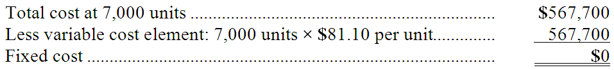  Variable selling and administrative cost per unit = Change in cost ÷ Change in activity  = ($624,400 - $612,600) ÷ (7,000 units - 6,000 units)  = $11,800 ÷ 1,000 units  = $11.80 per unit  Fixed cost of sales:  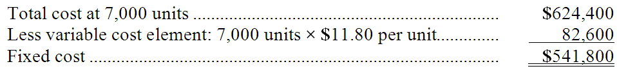  Total fixed cost = $0 + $541,800 = $541,800

AACSB: Analytic
AICPA BB: Critical Thinking
AICPA FN: Measurement
Blooms: Apply
Learning Objective: 02-03 Understand cost behavior patterns including variable costs; fixed costs; and mixed costs.
Learning Objective: 02-04 Analyze a mixed cost using a scattergraph plot and the high-low method.
Level: 2 Medium

64. | Bakker Corporation has provided the following production and average cost data for two levels of monthly production volume. The company produces a single product.  The best estimate of the total variable manufacturing cost per unit is:  A. $89.70  B. $131.80  C. $19.50  D. $112.30  Total manufacturing overhead at 5,000 units = 5,000 units × $60.30 per unit = $301,500  Total manufacturing overhead at 4,000 units = 4,000 units × $70.50 per unit = $282,000  Variable manufacturing overhead per unit = Change in cost ÷ Change in activity  = ($301,500 - $282,000) ÷ (5,000 units - 4,000 units)  = $19,500 ÷ 1,000 units  = $19.50 per unit  Total variable manufacturing cost = Direct materials + Direct labor + Variable manufacturing overhead  = $89.70 per unit + $22.60 per unit + $19.50 per unit  = $131.80 per unit

AACSB: Analytic
AICPA BB: Critical Thinking
AICPA FN: Measurement
Blooms: Apply
Learning Objective: 02-03 Understand cost behavior patterns including variable costs; fixed costs; and mixed costs.
Learning Objective: 02-04 Analyze a mixed cost using a scattergraph plot and the high-low method.
Level: 3 Hard

65. | Carbaugh Corporation has provided the following production and average cost data for two levels of monthly production volume. The company produces a single product.  The best estimate of the total cost to manufacture 3,300 units is closest to:  A. $637,560  B. $612,975  C. $588,390  D. $619,680  Total manufacturing overhead at 4,000 units = 4,000 units × $55.20 per unit = $220,800  Total manufacturing overhead at 3,000 units = 3,000 units × $70.10 per unit = $210,300  Variable manufacturing overhead per unit = Change in cost ÷ Change in activity  = ($220,800 - $210,300) ÷ (4,000 units - 3,000 units)  = $10,500 ÷ 1,000 units  = $10.50 per unit  Fixed cost element of manufacturing overhead = Total cost - Variable cost element  = $220,800 - 4,000 units × $10.50 per unit  = $220,800 - $42,000  = $178,800  Total variable manufacturing cost = Direct materials + Direct labor + Manufacturing overhead  = $73.90 per unit + $49.20 per unit + $10.50 per unit  = $133.60 per unit  Total manufacturing cost = Total manufacturing cost per unit × Total units manufactured + Total fixed manufacturing cost  = $133.60 per unit × 3,300 units + $178,800  = $440,880 + $178,800  = $619,680

AACSB: Analytic
AICPA BB: Critical Thinking
AICPA FN: Measurement
Blooms: Apply
Learning Objective: 02-03 Understand cost behavior patterns including variable costs; fixed costs; and mixed costs.
Learning Objective: 02-04 Analyze a mixed cost using a scattergraph plot and the high-low method.
Level: 3 Hard

66. | Edeen Corporation has provided the following production and total cost data for two levels of monthly production volume. The company produces a single product.  The best estimate of the total variable manufacturing cost per unit is:  A. $62.20  B. $96.50  C. $109.30  D. $12.80  Direct materials cost per unit = Change in cost ÷ Change in activity  = ($373,200 - $311,000) ÷ (6,000 units - 5,000 units)  = $62,200 ÷ 1,000 per unit  = $62.20 per unit  Direct labor cost per unit = Change in cost ÷ Change in activity  = ($205,800 - $171,500) ÷ (6,000 units - 5,000 units)  = $34,300 ÷ 1,000 units  = $34.30 per unit  Variable manufacturing overhead per unit = Change in cost ÷ Change in activity  = ($427,800 - $415,000) ÷ (6,000 units - 5,000 units)  = $12,800 ÷ 1,000 units  = $12.80 per unit  Total variable manufacturing cost per unit = Direct materials per unit + Direct labor per unit + Variable manufacturing overhead per unit = $62.20 per unit + $34.30 per unit + $12.80 per unit  = $109.30 per unit

AACSB: Analytic
AICPA BB: Critical Thinking
AICPA FN: Measurement
Blooms: Apply
Learning Objective: 02-03 Understand cost behavior patterns including variable costs; fixed costs; and mixed costs.
Learning Objective: 02-04 Analyze a mixed cost using a scattergraph plot and the high-low method.
Level: 2 Medium

67. | Dabney Corporation has provided the following production and total cost data for two levels of monthly production volume. The company produces a single product.  The best estimate of the total monthly fixed manufacturing cost is:  A. $778,400  B. $1,457,400  C. $1,505,900  D. $1,554,400  Direct materials cost per unit = Change in cost ÷ Change in activity  = ($281,600 - $246,400) ÷ (8,000 units - 7,000 units)  = $35,200 ÷ 1,000 units  = $35.20 per unit  Direct labor cost per unit = Change in cost ÷ Change in activity  = ($400,800 - $350,700) ÷ (8,000 units - 7,000 units)  = $50,100 ÷ 1,000 units  = $50.10 per unit  Variable manufacturing overhead cost per unit = Change in cost ÷ Change in activity  = ($872,000 - $860,300) ÷ (8,000 units - 7,000 units)  = $11,700 ÷ 1,000 units  = $11.70 per unit  Fixed cost element of manufacturing overhead = Total cost - Variable cost element  = $872,000 - 8,000 units × $11.70 per unit  = $872,000 - $93,600  = $778,400

AACSB: Analytic
AICPA BB: Critical Thinking
AICPA FN: Measurement
Blooms: Apply
Learning Objective: 02-03 Understand cost behavior patterns including variable costs; fixed costs; and mixed costs.
Learning Objective: 02-04 Analyze a mixed cost using a scattergraph plot and the high-low method.
Level: 2 Medium

68. | Haras Corporation is a wholesaler that sells a single product. Management has provided the following cost data for two levels of monthly sales volume. The company sells the product for $141.30 per unit.  The best estimate of the total variable cost per unit is:  A. $123.40  B. $79.60  C. $57.90  D. $130.70  Variable cost of sales = Change in cost ÷ Change in activity  = ($405,300 - $347,400) ÷ (7,000 units - 6,000 units)  = $57,900 ÷ 1,000 units  = $57.90 per unit  Variable selling and administrative cost = Change in cost ÷ Change in activity  = ($458,500 - $436,800) ÷ (7,000 units - 6,000 units)  = $21,700 ÷ 1,000 units  = $21.70 per unit  Total variable cost = Variable cost of sales + Variable selling and administrative cost  = $57.90 per unit + $21.70 per unit  = $79.60 per unit

AACSB: Analytic
AICPA BB: Critical Thinking
AICPA FN: Measurement
Blooms: Apply
Learning Objective: 02-03 Understand cost behavior patterns including variable costs; fixed costs; and mixed costs.
Learning Objective: 02-04 Analyze a mixed cost using a scattergraph plot and the high-low method.
Level: 2 Medium

69. | Faraz Corporation has provided the following production and total cost data for two levels of monthly production volume. The company produces a single product.  The best estimate of the total cost to manufacture 5,300 units is closest to:  A. $1,002,230  B. $1,021,780  C. $1,063,180  D. $941,280  Direct materials is a variable cost, so it can be computed as follows:  Direct materials cost per unit = $70,500/5,000 units = $14.10 per unit  Direct labor could also be computed the same way, but just to make sure it is purely a variable cost, we'll use the high-low method:  Variable direct labor cost per unit = Change in cost ÷ Change in activity  = ($156,600 - $130,500) ÷ (6,000 units - 5,000 units)  = $26,100 ÷ 1,000 units  = $26.10 per unit  Direct labor fixed cost element = Total cost - Variable cost element  = $156,600 - ($26.10 per unit × 6,000 units)  = $156,600 - ($156,600) = $0  Variable manufacturing overhead cost per unit = Change in cost ÷ Change in activity  = ($824,400 - $802,000) ÷ (6,000 units - 5,000 units)  = $22,400 ÷ 1,000 units  = $22.40 per unit  Manufacturing overhead fixed cost element = Total cost - Variable cost element  = $824,400 - ($22.40 per unit × 6,000 units)  = $824,400 - ($134,400) = $690,000  Total variable cost = Direct materials + Direct labor + Variable manufacturing overhead  = $14.10 per unit + $26.10 per unit + $22.40 per unit  = $62.60 per unit  Total fixed overhead cost = $690,000  Total cost to manufacture 5,300 units = Total fixed cost + Total variable cost  = $690,000 + ($62.60 per unit × 5,300 units)  = $690,000 + ($331,780)  = $1,021,780

AACSB: Analytic
AICPA BB: Critical Thinking
AICPA FN: Measurement
Blooms: Apply
Learning Objective: 02-03 Understand cost behavior patterns including variable costs; fixed costs; and mixed costs.
Learning Objective: 02-04 Analyze a mixed cost using a scattergraph plot and the high-low method.
Level: 2 Medium

70. | Anderwald Corporation has provided the following production and average cost data for two levels of monthly production volume. The company produces a single product.  The best estimate of the total monthly fixed manufacturing cost is:  A. $360,800  B. $136,800  C. $196,800  D. $176,800  Both direct materials and direct labor are variable costs.  Total manufacturing overhead at 2,000 units = $88.40 per unit × 2,000 units = $176,800  Total manufacturing overhead at 3,000 units = $65.60 per unit × 3,000 units = $196,800  Variable element of manufacturing overhead = Change in cost ÷ Change in activity  = ($196,800 - $176,800) ÷ (3,000 units - 2,000 units)  = $20,000 ÷ 1,000 units  = $20 per unit  Fixed cost element of manufacturing overhead = Total cost - Total variable cost  = $196,800 - ($20.00 per unit × 3,000 units)  = $196,800 - ($60,000)  = $136,800

AACSB: Analytic
AICPA BB: Critical Thinking
AICPA FN: Measurement
Blooms: Apply
Learning Objective: 02-03 Understand cost behavior patterns including variable costs; fixed costs; and mixed costs.
Learning Objective: 02-04 Analyze a mixed cost using a scattergraph plot and the high-low method.
Level: 3 Hard

71. | Anaconda Mining Company shipped 9,000 tons of copper concentrate for $450,000 in March and 11,000 tons for $549,000 in April. Shipping costs for 12,000 tons to be shipped in May would be expected to be:  A. $548,780  B. $549,020  C. $594,000  D. $598,500  Variable shipping cost per ton = Change in cost ÷ Change in activity  = ($549,000 - $450,000) ÷ (11,000 tons - 9,000 tons)  = $99,000 ÷ 2,000 tons  = $49.50 per ton  Fixed cost element of shipping cost = Total cost - Total variable cost  = $549,000 - ($49.50 per ton × 11,000 tons)  = $549,000 - $544,500  = $4,500  Total shipping cost = $4,500 + $49.50 per ton × 12,000 tons = $4,500 + $594,000 = $598,500

AACSB: Analytic
AICPA BB: Critical Thinking
AICPA FN: Measurement
Blooms: Apply
Learning Objective: 02-03 Understand cost behavior patterns including variable costs; fixed costs; and mixed costs.
Learning Objective: 02-04 Analyze a mixed cost using a scattergraph plot and the high-low method.
Level: 2 Medium

72. | Average maintenance costs are $1.50 per machine-hour at an activity level of 8,000 machine-hours and $1.20 per machine-hour at an activity level of 13,000 machine-hours. Assuming that this activity is within the relevant range, total expected maintenance cost for a budgeted activity level of 10,000 machine-hours would be closest to:  A. $16,128  B. $15,000  C. $13,440  D. $11,433  Average maintenance cost = Total maintenance cost ÷ Total activity  At 8,000 machine-hours:  $1.50 per machine-hour = Total maintenance cost ÷ 8,000 machine-hours  Total maintenance cost = 8,000 machine-hours × $1.50 per machine-hour = $12,000  At 13,000 machine-hours:  $1.20 per machine-hour = Total maintenance cost ÷ 13,000 machine-hours  Total maintenance cost = 13,000 machine-hours × $1.20 per machine-hour = $15,600  Variable cost = Change in cost ÷ Change in activity  = ($15,600 - $12,000) ÷ (13,000 machine-hours - 8,000 machine hours)  = $3,600 ÷ 5,000 machine-hours  = $0.72 per machine-hour  Total fixed cost = Total cost - Total variable cost  = $15,600 - ($0.72 per machine-hour × 13,000 machine-hours)  = $15,600 - $9,360  = $6,240  Total cost = Total fixed cost + Total variable cost  = $6,240 + $0.72 per machine-hour × 10,000 machine-hours  = $6,240 + $7,200  = $13,440

AACSB: Analytic
AICPA BB: Critical Thinking
AICPA FN: Measurement
Blooms: Apply
Learning Objective: 02-03 Understand cost behavior patterns including variable costs; fixed costs; and mixed costs.
Learning Objective: 02-04 Analyze a mixed cost using a scattergraph plot and the high-low method.
Level: 3 Hard

73. | The following data pertains to activity and the cost of cleaning and maintenance for two recent months:  The best estimate of the total month 1 variable cost for cleaning and maintenance is:  A. $300  B. $500  C. $800  D. $100  Cleaning and maintenance  Variable cost per unit = Change in cost ÷ Change in activity  = ($1,100 - $900) ÷ (2,500 units - 2,000 units)  = $200 ÷ 500 units  = $0.40 per unit  Total variable cost at 22,000 units = 2,000 units × $0.40 per unit  = $800

AACSB: Analytic
AICPA BB: Critical Thinking
AICPA FN: Measurement
Blooms: Apply
Learning Objective: 02-03 Understand cost behavior patterns including variable costs; fixed costs; and mixed costs.
Level: 2 Medium

74. | The following data pertains to activity and costs for two months:  Assuming that these activity levels are within the relevant range, the mixed cost for July was:  A. $10,000  B. $35,000  C. $15,000  D. $40,000  Variable cost per unit = $20,000 ÷ 10,000 units = $2 per unit  Total variable cost in July = $2 per unit × 20,000 units = $40,000 per unit  Fixed cost = $15,000 (given)  Total cost = Variable cost + Fixed cost + Mixed cost  $70,000 = $40,000 + $15,000 + Mixed cost  Mixed cost = $70,000 - ($40,000 + $15,000)  = $70,000 - $55,000  = $15,000

AACSB: Analytic
AICPA BB: Critical Thinking
AICPA FN: Measurement
Blooms: Apply
Learning Objective: 02-03 Understand cost behavior patterns including variable costs; fixed costs; and mixed costs.
Level: 3 Hard

75. | At an activity level of 9,200 machine-hours in a month, Nooner Corporation's total variable production engineering cost is $761,300 and its total fixed production engineering cost is $154,008. What would be the total production engineering cost per unit, both fixed and variable, at an activity level of 9,300 machine-hours in a month? Assume that this level of activity is within the relevant range.  A. $98.42  B. $99.49  C. $99.31  D. $98.96  Variable cost per unit = $761,300 ÷ 9,200 units = $82.75 per unit  Fixed cost per unit at 9,300 units = $154,008 ÷ 9,300 units = $16.56 per unit  Total cost = Variable cost + Fixed cost  = $82.75 per unit + $16.56 per unit  = $99.31 per unit

AACSB: Analytic
AICPA BB: Critical Thinking
AICPA FN: Measurement
Blooms: Apply
Learning Objective: 02-03 Understand cost behavior patterns including variable costs; fixed costs; and mixed costs.
Level: 1 Easy

76. | Jumpst Corporation uses the cost formula Y = $3,600 + $0.30X for the maintenance cost in Department B, where X is machine-hours. The August budget is based on 20,000 hours of planned machine time. Maintenance cost expected to be incurred during August is:  A. $3,600  B. $6,000  C. $6,300  D. $9,600  Y = $3,600 + $0.30 per unit × X  = $3,600 + $0.30 per unit × 20,000 hours  = $3,600 + $6,000  = $9,600

AACSB: Analytic
AICPA BB: Critical Thinking
AICPA FN: Measurement
Blooms: Apply
Learning Objective: 02-03 Understand cost behavior patterns including variable costs; fixed costs; and mixed costs.
Level: 1 Easy

77. | Given the cost formula, Y = $9,000 + $2.50X, total cost for an activity level of 3,000 units would be:  A. $9,750  B. $12,000  C. $16,500  D. $7,500  Y = $9,000 + $2.50 per unit × X  = $9,000 + $2.50 per unit × 3,000 units  = $9,000 + $7,500  = $16,500

AACSB: Analytic
AICPA BB: Critical Thinking
AICPA FN: Measurement
Blooms: Apply
Learning Objective: 02-03 Understand cost behavior patterns including variable costs; fixed costs; and mixed costs.
Level: 1 Easy

78. | Blore Corporation reports that at an activity level of 7,300 units, its total variable cost is $511,803 and its total fixed cost is $76,650. What would be the total cost, both fixed and variable, at an activity level of 7,500 units? Assume that this level of activity is within the relevant range.  A. $604,575  B. $602,475  C. $596,514  D. $588,453  Variable cost per unit = $511,803 ÷ 7,300 units = $70.11 unit  Total cost = Total fixed cost + Total variable cost  = $76,650 + $70.11 per unit × 7,500 units  = $76,650 + $525,825  = $602,475

AACSB: Analytic
AICPA BB: Critical Thinking
AICPA FN: Measurement
Blooms: Apply
Learning Objective: 02-03 Understand cost behavior patterns including variable costs; fixed costs; and mixed costs.
Level: 1 Easy

79. | Given the cost formula Y = $15,000 + $5X, total cost at an activity level of 8,000 units would be:  A. $23,000  B. $15,000  C. $55,000  D. $40,000  Y = $15,000 + $5 per unit × 8,000 units  Y = $15,000 + $40,000  Y = $55,000

AACSB: Analytic
AICPA BB: Critical Thinking
AICPA FN: Measurement
Blooms: Apply
Learning Objective: 02-03 Understand cost behavior patterns including variable costs; fixed costs; and mixed costs.
Level: 1 Easy

80. | At a volume of 10,000 units, Company P incurs $30,000 in factory overhead costs, including $10,000 in fixed costs. Assuming that this activity is within the relevant range, if volume increases to 12,000 units, Company P would expect to incur total factory overhead costs of:  A. $36,000  B. $34,000  C. $30,000  D. $32,000  Total cost = Fixed cost + Variable cost  $30,000 = $10,000 + Variable costs  Variable cost = $30,000 - $10,000  Variable cost = $20,000  Variable costs per unit = $20,000 ÷ 10,000 units = $2 per unit  Total cost = Total fixed cost + Total variable cost  = $10,000 + $2 per unit × 12,000 units  = $10,000 + $24,000  = $34,000

AACSB: Analytic
AICPA BB: Critical Thinking
AICPA FN: Measurement
Blooms: Apply
Learning Objective: 02-03 Understand cost behavior patterns including variable costs; fixed costs; and mixed costs.
Level: 1 Easy

81. | At an activity level of 4,400 units in a month, Goldbach Corporation's total variable maintenance and repair cost is $313,632 and its total fixed maintenance and repair cost is $93,104. What would be the total maintenance and repair cost, both fixed and variable, at an activity level of 4,600 units in a month? Assume that this level of activity is within the relevant range.  A. $420,992  B. $425,224  C. $415,980  D. $406,736  Variable cost per unit = $313,632 ÷ 4,400 units = $71.28 unit  Total cost = Total fixed cost + Total variable cost  = $93,104 + $71.28 per unit × 4,600 units  = $93,104 + $327,888  = $420,992

AACSB: Analytic
AICPA BB: Critical Thinking
AICPA FN: Measurement
Blooms: Apply
Learning Objective: 02-03 Understand cost behavior patterns including variable costs; fixed costs; and mixed costs.
Level: 1 Easy

82. | Supply costs at Lattea Corporation's chain of gyms are listed below:  Management believes that supply cost is a mixed cost that depends on client-visits. Using the high-low method to estimate the variable and fixed components of this cost, those estimates would be closest to:  A. $2.44 per client-visit; $28,623 per month  B. $1.33 per client-visit; $12,768 per month  C. $0.79 per client-visit; $19,321 per month  D. $0.75 per client-visit; $19,826 per month  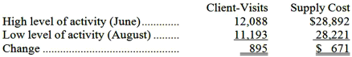  Variable cost per unit = Change in cost ÷ Change in activity  = $671 ÷ 895 client-visits  = $0.75 per client-visit  Fixed cost = Total cost - Variable cost element  = $28,892 - ($0.75 per unit × 12,088 client-visits)  = $28,892 - $9,066  = $19,826

AACSB: Analytic
AICPA BB: Critical Thinking
AICPA FN: Measurement
Blooms: Apply
Learning Objective: 02-04 Analyze a mixed cost using a scattergraph plot and the high-low method.
Level: 1 Easy

83. | Electrical costs at one of Vanartsdalen Corporation's factories are listed below:  Management believes that electrical cost is a mixed cost that depends on machine-hours. Using the high-low method to estimate the variable and fixed components of this cost, these estimates would be closest to:  A. $14.41 per machine-hour; $33,832 per month  B. $0.11 per machine-hour; $33,957 per month  C. $9.35 per machine-hour; $11,885 per month  D. $11.30 per machine-hour; $7,229 per month  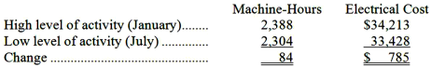  Variable cost per unit = Change in cost ÷ Change in activity  = $785 ÷ 84 machine-hours  = $9.35 per machine-hour  Fixed cost = Total cost - Variable cost element  = $34,213 - ($9.35 per machine-hour × 2,388 machine-hours)  = $34,213 - $22,328  = $11,885

AACSB: Analytic
AICPA BB: Critical Thinking
AICPA FN: Measurement
Blooms: Apply
Learning Objective: 02-04 Analyze a mixed cost using a scattergraph plot and the high-low method.
Level: 1 Easy

84. | A soft drink bottler incurred the following plant utility costs: 1,800 units bottled with utility costs of $5,750, and 1,500 units bottled with utility costs of $5,200. What is the variable cost per unit bottled (Use the High-low method. Round to the nearest cent.)  A. $3.47  B. $3.19  C. $1.83  D. None of these is true.  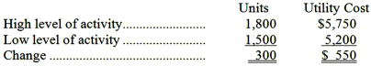  Variable cost per unit = Change in cost ÷ Change in activity  = $550 ÷ 300 units  = $1.83 per unit

AACSB: Analytic
AICPA BB: Critical Thinking
AICPA FN: Measurement
Blooms: Apply
Learning Objective: 02-04 Analyze a mixed cost using a scattergraph plot and the high-low method.
Level: 1 Easy

85. | The following data pertains to activity and maintenance costs for two recent years:  Using the high-low method, the cost formula for maintenance would be:  A. $1.50 per unit  B. $1.25 per unit  C. $3,000 plus $1.50 per unit  D. $6,000 plus $0.75 per unit  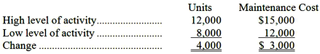  Variable cost per unit = Change in cost ÷ Change in activity  = $3,000 ÷ 4,000 units  = $0.75 per unit  Fixed cost = Total cost - Variable cost element  = $15,000 - ($0.75 per unit × 12,000 units)  = $15,000 - $9,000  = $6,000

AACSB: Analytic
AICPA BB: Critical Thinking
AICPA FN: Measurement
Blooms: Apply
Learning Objective: 02-04 Analyze a mixed cost using a scattergraph plot and the high-low method.
Level: 1 Easy

86. | The following data pertains to activity and utility costs for two recent years:  Using the high-low method, the cost formula for utilities is:  A. $1.50 per unit  B. $1.20 per unit  C. $3,000 plus $3.00 per unit  D. $4,500 plus $0.75 per unit  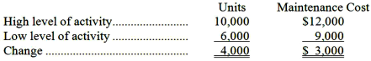  Variable cost per unit = Change in cost ÷ Change in activity  = $3,000 ÷ 4,000 units  = $0.75 per unit  Fixed cost = Total cost - Variable cost element  = $12,000 - ($0.75 per unit × 10,000 units)  = $12,000 - $7,500  = $4,500

AACSB: Analytic
AICPA BB: Critical Thinking
AICPA FN: Measurement
Blooms: Apply
Learning Objective: 02-04 Analyze a mixed cost using a scattergraph plot and the high-low method.
Level: 1 Easy

87. | Maintenance costs at a Tierce Corporation factory are listed below:  Management believes that maintenance cost is a mixed cost that depends on machine-hours. Using the high-low method to estimate the variable and fixed components of this cost, these estimates would be closest to:  A. $14.54 per machine-hour; $52,671 per month  B. $9.27 per machine-hour; $19,076 per month  C. $0.11 per machine-hour; $52,591 per month  D. $9.27 per machine-hour; $19,071 per month  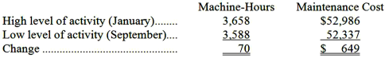  Variable cost per unit = Change in cost ÷ Change in activity  = $649 ÷ 70 machine-hours  = $9.27 per machine-hour  Fixed cost = Total cost - Variable cost element  = $52,986 - ($9.27 per machine-hour × 3,658 machine-hours)  = $52,986 - $33,910  = $19,076

AACSB: Analytic
AICPA BB: Critical Thinking
AICPA FN: Measurement
Blooms: Apply
Learning Objective: 02-04 Analyze a mixed cost using a scattergraph plot and the high-low method.
Level: 1 Easy

88. | Buckeye Company has provided the following data for maintenance cost:  The best estimate of the cost formula for maintenance would be:  A. $21,625 per year plus $0.625 per machine hour  B. $7,000 per year plus $0.625 per machine hour  C. $7,000 per year plus $1.60 per machine hour  D. $27,000 per year plus $1.60 per machine hour  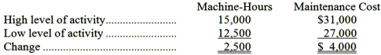  Variable cost per unit = Change in cost ÷ Change in activity  = $4,000 ÷ 2,500 machine-hours  = $1.60 per machine-hour  Fixed cost = Total cost - Variable cost element  = $31,000 - ($1.60 per machine-hour × 15,000 machine-hours)  = $31,000 - $24,000  = $7,000

AACSB: Analytic
AICPA BB: Critical Thinking
AICPA FN: Measurement
Blooms: Apply
Learning Objective: 02-04 Analyze a mixed cost using a scattergraph plot and the high-low method.
Level: 2 Medium

89. | Haar Inc. is a merchandising company. Last month the company's cost of goods sold was $61,000. The company's beginning merchandise inventory was $11,000 and its ending merchandise inventory was $21,000. What was the total amount of the company's merchandise purchases for the month?  A. $61,000  B. $51,000  C. $71,000  D. $93,000  Purchases = Cost of goods sold + Ending merchandise inventory - Beginning merchandise inventory  = $61,000 + $21,000 - $11,000  = $71,000

AACSB: Analytic
AICPA BB: Critical Thinking
AICPA FN: Measurement
Blooms: Apply
Learning Objective: 02-05 Prepare income statements for a merchandising company using the traditional and contribution formats.
Level: 2 Medium

90. | Gabruk Inc. is a merchandising company. Last month the company's merchandise purchases totaled $88,000. The company's beginning merchandise inventory was $15,000 and its ending merchandise inventory was $13,000. What was the company's cost of goods sold for the month?  A. $88,000  B. $90,000  C. $86,000  D. $116,000  Cost of goods sold = Beginning merchandise inventory + purchases - Ending merchandise inventory  = $15,000 + $88,000 - $13,000  = $90,000

AACSB: Analytic
AICPA BB: Critical Thinking
AICPA FN: Measurement
Blooms: Apply
Learning Objective: 02-05 Prepare income statements for a merchandising company using the traditional and contribution formats.
Level: 1 Easy

A partial listing of costs incurred during December at Gagnier Corporation appears below:

91. | The total of the period costs listed above for December is:  A. $89,000  B. $310,000  C. $325,000  D. $399,000  Period costs = Administrative wages and salaries + Sales staff salaries + Corporate headquarters building rent + Marketing  = $105,000 + $68,000 + $34,000 + $103,000  = $310,000

AACSB: Analytic
AICPA BB: Critical Thinking
AICPA FN: Measurement
Blooms: Apply
Learning Objective: 02-02 Distinguish between product cost and period costs and give examples of each.
Level: 2 Medium

92. | The total of the manufacturing overhead costs listed above for December is:  A. $325,000  B. $635,000  C. $89,000  D. $40,000  Manufacturing overhead costs = Factory supplies + Factory depreciation + Indirect labor  = $8,000 + $49,000 + $32,000  = $89,000

AACSB: Analytic
AICPA BB: Critical Thinking
AICPA FN: Measurement
Blooms: Apply
Learning Objective: 02-01 Identify and give examples of each of the three basic manufacturing cost categories.
Level: 2 Medium

93. | The total of the product costs listed above for December is:  A. $310,000  B. $89,000  C. $635,000  D. $325,000  Product costs = Direct materials + Direct labor + Manufacturing overhead  = $153,000 + $83,000 + $89,000  = $325,000

AACSB: Analytic
AICPA BB: Critical Thinking
AICPA FN: Measurement
Blooms: Apply
Learning Objective: 02-02 Distinguish between product cost and period costs and give examples of each.
Level: 2 Medium

A partial listing of costs incurred at Backes Corporation during November appears below:

94. | The total of the manufacturing overhead costs listed above for November is:  A. $348,000  B. $31,000  C. $592,000  D. $77,000  Manufacturing overhead costs = Utilities, factory + Indirect labor + Depreciation of production equipment  = $6,000 + $25,000 + $46,000  = $77,000

AACSB: Analytic
AICPA BB: Critical Thinking
AICPA FN: Measurement
Blooms: Apply
Learning Objective: 02-01 Identify and give examples of each of the three basic manufacturing cost categories.
Level: 2 Medium

95. | The total of the product costs listed above for November is:  A. $77,000  B. $348,000  C. $592,000  D. $244,000  Product costs = Direct materials + Direct labor + Manufacturing overhead  = $157,000 + $114,000 + $77,000  = $348,000

AACSB: Analytic
AICPA BB: Critical Thinking
AICPA FN: Measurement
Blooms: Apply
Learning Objective: 02-02 Distinguish between product cost and period costs and give examples of each.
Level: 2 Medium

96. | The total of the period costs listed above for November is:  A. $244,000  B. $321,000  C. $348,000  D. $77,000  Period costs = Administrative salaries + Sales commissions + Depreciation of administrative equipment + Advertising  = $99,000 + $54,000 + $30,000 + $61,000  = $244,000

AACSB: Analytic
AICPA BB: Critical Thinking
AICPA FN: Measurement
Blooms: Apply
Learning Objective: 02-02 Distinguish between product cost and period costs and give examples of each.
Level: 2 Medium

Dickison Corporation reported the following data for the month of December:

97. | The conversion cost for December was:  A. $107,000  B. $142,000  C. $111,000  D. $178,000  Conversion cost = Direct labor + Manufacturing overhead  = $38,000 + $69,000  = $107,000

AACSB: Analytic
AICPA BB: Critical Thinking
AICPA FN: Measurement
Blooms: Apply
Learning Objective: 02-01 Identify and give examples of each of the three basic manufacturing cost categories.
Level: 1 Easy

98. | The prime cost for December was:  A. $109,000  B. $111,000  C. $107,000  D. $66,000  Prime cost = Direct materials + Direct labor  = $71,000 + $38,000  = $109,000

AACSB: Analytic
AICPA BB: Critical Thinking
AICPA FN: Measurement
Blooms: Apply
Learning Objective: 02-01 Identify and give examples of each of the three basic manufacturing cost categories.
Level: 1 Easy

Management of Mcentire Corporation has asked your help as an intern in preparing some key reports for April. Direct materials cost was $64,000, direct labor cost was $47,000, and manufacturing overhead was $75,000. Selling expense was $15,000 and administrative expense was $44,000.

99. | The conversion cost for April was:  A. $186,000  B. $100,000  C. $128,000  D. $122,000  Conversion cost = Direct labor + Manufacturing overhead  = $47,000 + $75,000  = $122,000

AACSB: Analytic
AICPA BB: Critical Thinking
AICPA FN: Measurement
Blooms: Apply
Learning Objective: 02-01 Identify and give examples of each of the three basic manufacturing cost categories.
Level: 1 Easy

100. | The prime cost for April was:  A. $59,000  B. $122,000  C. $100,000  D. $111,000  Prime cost = Direct materials + Direct labor  = $64,000 + $47,000  = $111,000

AACSB: Analytic
AICPA BB: Critical Thinking
AICPA FN: Measurement
Blooms: Apply
Learning Objective: 02-01 Identify and give examples of each of the three basic manufacturing cost categories.
Level: 1 Easy

Callander Corporation is a wholesaler that sells a single product. Management has provided the following cost data for two levels of monthly sales volume. The company sells the product for $151.60 per unit.

101. | The best estimate of the total monthly fixed cost is:  A. $846,000  B. $886,050  C. $365,400  D. $926,100  Cost of sales is a variable cost.  Selling and administrative costs:  Variable cost per unit = Change in cost ÷ Change in activity  = ($441,000 - $430,200) ÷ (7,000 units - 6,000 units)  = $10,800 ÷ 1,000 units  = $10.80 per unit  Fixed cost = Total cost - Variable cost element  = $441,000 - ($10.80 per unit × 7,000 units)  = $441,000 - $75,600  = $365,400

AACSB: Analytic
AICPA BB: Critical Thinking
AICPA FN: Measurement
Blooms: Apply
Learning Objective: 02-04 Analyze a mixed cost using a scattergraph plot and the high-low method.
Level: 2 Medium

102. | The best estimate of the total variable cost per unit is:  A. $141.00  B. $80.10  C. $69.30  D. $132.30  Cost of sales:  Because cost of sales is a variable cost, there are several ways to compute the variable cost per unit. Here is one:  Variable cost per unit = Change in cost ÷ Change in activity  = ($485,100 - $415,800) ÷ (7,000 units - 6,000 units)  = $69,300 ÷ 1000 units  = $69.30 per unit  Selling and administrative costs:  Variable cost per unit = Change in cost ÷ Change in activity  = ($441,000 - $430,200) ÷ (7,000 units - 6,000 units)  = $10,800 ÷ 1000 units  = $10.80 per unit  Total cost per unit = $69.30 per unit + $10.80 per unit = $80.10

AACSB: Analytic
AICPA BB: Critical Thinking
AICPA FN: Measurement
Blooms: Apply
Learning Objective: 02-04 Analyze a mixed cost using a scattergraph plot and the high-low method.
Level: 2 Medium

103. | The best estimate of the total contribution margin when 6,300 units are sold is:  A. $450,450  B. $518,490  C. $121,590  D. $66,780  Contribution margin per unit = Selling price per unit - Variable cost per unit  = $151.60 per unit - $80.10 per unit  = $71.50 per unit  Total contribution margin = Contribution margin per unit × Unit sales  = $71.50 per unit × 6,300 units  = $450,450

AACSB: Analytic
AICPA BB: Critical Thinking
AICPA FN: Measurement
Blooms: Apply
Learning Objective: 02-03 Understand cost behavior patterns including variable costs; fixed costs; and mixed costs.
Learning Objective: 02-04 Analyze a mixed cost using a scattergraph plot and the high-low method.
Learning Objective: 02-05 Prepare income statements for a merchandising company using the traditional and contribution formats.
Level: 2 Medium

Babuca Corporation has provided the following production and total cost data for two levels of monthly production volume. The company produces a single product.

104. | The best estimate of the total monthly fixed manufacturing cost is:  A. $1,424,400  B. $1,506,400  C. $932,400  D. $1,465,400  Direct materials is a variable cost.  Direct labor is usually a variable cost, but it doesn't hurt to check.  Variable cost per unit = Change in cost ÷ Change in activity  = ($94,500 - $81,000) ÷ (7,000 units - 6,000 units)  = $13,500 ÷ 1,000 units  = $13.50 per unit  Fixed cost = Total cost - Variable cost element  = $94,500 - ($13.50 per unit × 7,000 units)  = $94,500 - 94,500  = $0  Manufacturing overhead:  Variable cost per unit = Change in cost ÷ Change in activity  = ($1,015,000- $1,003,200) ÷ (7,000 units - 6,000 units)  = $11,800 ÷ 1,000 units  = $11.80 per unit  Fixed cost = Total cost - Variable cost element  = $1,015,000 - ($11.80 per unit × 7,000 units)  = $1,015,000 - $82,600  = $932,400  Total fixed cost per month = $0 + $932,400 = $932,400

AACSB: Analytic
AICPA BB: Critical Thinking
AICPA FN: Measurement
Blooms: Apply
Learning Objective: 02-04 Analyze a mixed cost using a scattergraph plot and the high-low method.
Level: 2 Medium

105. | The best estimate of the total variable manufacturing cost per unit is:  A. $82.00  B. $70.20  C. $56.70  D. $11.80  Note: There are several ways to computer the variable cost per unit for direct materials and direct labor.  Direct materials:  Variable cost per unit = Change in cost ÷ Change in activity  = ($396,900 - $340,200) ÷ (7,000 units - 6,000 units)  = $56,700 ÷ 1,000 units  = $56.70 per unit  Direct labor:  Variable cost per unit = Change in cost ÷ Change in activity  = ($94,500 - $81,000) ÷ (7,000 units - 6,000 units)  = $13,500 ÷ 1,000 units  = $13.50 per unit  Manufacturing overhead  Variable cost per unit = Change in cost ÷ Change in activity  = ($1,015,000- $1,003,200) ÷ (7,000 units - 6,000 units)  = $11,800 ÷ 1,000 units  = $11.80 per unit  Total variable cost per unit = $56.70 per unit + $13.50 per unit + $11.80 per unit  = $82.00 per unit

AACSB: Analytic
AICPA BB: Critical Thinking
AICPA FN: Measurement
Blooms: Apply
Learning Objective: 02-04 Analyze a mixed cost using a scattergraph plot and the high-low method.
Level: 2 Medium

106. | The best estimate of the total cost to manufacture 6,300 units is closest to:  A. $1,425,690  B. $1,355,760  C. $1,495,620  D. $1,449,000  See earlier parts for the variable cost per unit and the total fixed cost.  Total cost = Total fixed cost + Total variable cost  = $932,400 + ($82.00 per units × 6,300 units)  = $932,400 + $516,600  = $1,449,000

AACSB: Analytic
AICPA BB: Critical Thinking
AICPA FN: Measurement
Blooms: Apply
Learning Objective: 02-03 Understand cost behavior patterns including variable costs; fixed costs; and mixed costs.
Learning Objective: 02-04 Analyze a mixed cost using a scattergraph plot and the high-low method.
Level: 2 Medium

The following production and average cost data for two levels of monthly production volume have been supplied by a company that produces a single product:

107. | The best estimate of the total monthly fixed manufacturing cost is:  A. $25,600  B. $114,400  C. $47,700  D. $69,800  Total manufacturing overhead at 1,000 units = 1,000 units × $47.70 per unit = $47,700  Total manufacturing overhead at 2,000 units = 2,000 units × $34.90 per unit = $69,800  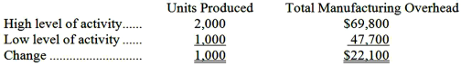  Variable cost per unit = Change in cost ÷ Change in activity  = $22,100 ÷ 1,000 units  = $22.10 per unit  Fixed cost = Total cost - Variable cost element  = $69,800 - ($22.10 per unit × 2,000 units)  = $69,800 - $44,200  = $25,600

AACSB: Analytic
AICPA BB: Critical Thinking
AICPA FN: Measurement
Blooms: Apply
Learning Objective: 02-04 Analyze a mixed cost using a scattergraph plot and the high-low method.
Level: 3 Hard

108. | The best estimate of the total variable manufacturing cost per unit is:  A. $22.10  B. $66.70  C. $88.80  D. $15.70  Total manufacturing overhead at 1,000 units = 1,000 units × $47.70 per unit = $47,700  Total manufacturing overhead at 2,000 units = 2,000 units × $34.90 per unit = $69,800  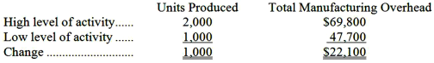  Variable cost per unit = Change in cost ÷ Change in activity  = $22,100 ÷ 1,000 units  = $22.10 per unit  Total variable cost per unit = Direct materials per unit + Direct labor per unit + variable manufacturing overhead per unit  = $15.70 + $51.00 + $22.10  = $88.80

AACSB: Analytic
AICPA BB: Critical Thinking
AICPA FN: Measurement
Blooms: Apply
Learning Objective: 02-04 Analyze a mixed cost using a scattergraph plot and the high-low method.
Level: 3 Hard

109. | The best estimate of the total cost to manufacture 1,200 units is closest to:  A. $132,160  B. $121,920  C. $129,600  D. $137,280  From earlier parts, the total fixed cost is $25,600 and the variable cost per unit is $88.80.  Total cost = Total fixed cost + Total variable cost  = $25,600 + ($88.80 per unit × 1,200 units)  = $25,600 + $106,560  = $132,160

AACSB: Analytic
AICPA BB: Critical Thinking
AICPA FN: Measurement
Blooms: Apply
Learning Objective: 02-03 Understand cost behavior patterns including variable costs; fixed costs; and mixed costs.
Learning Objective: 02-04 Analyze a mixed cost using a scattergraph plot and the high-low method.
Level: 3 Hard

Erkkila Inc. reports that at an activity level of 7,900 machine-hours in a month, its total variable inspection cost is $210,061 and its total fixed inspection cost is $191,970.

110. | What would be the average fixed inspection cost per unit at an activity level of 8,100 machine-hours in a month? Assume that this level of activity is within the relevant range.  A. $50.89  B. $24.30  C. $23.70  D. $32.96  Average fixed inspection cost = Total fixed inspection cost ÷ Total activity  = $191,970 ÷ 8,100 machine-hours  = $23.70 per machine-hour

AACSB: Analytic
AICPA BB: Critical Thinking
AICPA FN: Measurement
Blooms: Apply
Learning Objective: 02-03 Understand cost behavior patterns including variable costs; fixed costs; and mixed costs.
Level: 1 Easy

111. | What would be the total variable inspection cost at an activity level of 8,100 machine-hours in a month? Assume that this level of activity is within the relevant range.  A. $210,061  B. $196,830  C. $215,379  D. $402,031  Variable inspection cost per unit = Total variable inspection cost ÷ Total activity  = $210,061 ÷ 7,900 machine-hours  = $26.59 per machine-hour  Total variable inspection cost = Variable inspection cost per unit × Total activity  = $26.59 per machine-hour × 8,100 machine-hours  = $215,379

AACSB: Analytic
AICPA BB: Critical Thinking
AICPA FN: Measurement
Blooms: Apply
Learning Objective: 02-03 Understand cost behavior patterns including variable costs; fixed costs; and mixed costs.
Level: 1 Easy

At an activity level of 5,300 machine-hours in a month, Clyburn Corporation's total variable maintenance cost is $114,268 and its total fixed maintenance cost is $154,336.

112. | What would be the total variable maintenance cost at an activity level of 5,600 machine-hours in a month? Assume that this level of activity is within the relevant range.  A. $163,072  B. $268,604  C. $114,268  D. $120,736  Variable maintenance cost per unit = Total variable maintenance cost ÷ Total activity  = $114,268 ÷ 5,300 machine-hours  Total variable maintenance cost = Variable maintenance cost per unit × Total activity  = $21.56 per machine-hours × 5,600 machine-hours  = $120,736

AACSB: Analytic
AICPA BB: Critical Thinking
AICPA FN: Measurement
Blooms: Apply
Learning Objective: 02-03 Understand cost behavior patterns including variable costs; fixed costs; and mixed costs.
Level: 1 Easy

113. | What would be the average fixed maintenance cost per unit at an activity level of 5,600 machine-hours in a month? Assume that this level of activity is within the relevant range.  A. $50.68  B. $27.56  C. $35.79  D. $29.12  Average fixed maintenance cost = Total fixed maintenance cost ÷ Total activity = $154,336 ÷ 5,600 machine-hours = $27.56 per machine-hours

AACSB: Analytic
AICPA BB: Critical Thinking
AICPA FN: Measurement
Blooms: Apply
Learning Objective: 02-03 Understand cost behavior patterns including variable costs; fixed costs; and mixed costs.
Level: 1 Easy

Slappy Corporation leases its corporate headquarters building. This lease cost is fixed with respect to the company's sales volume. In a recent month in which the sales volume was 20,000 units, the lease cost was $482,000.

114. | To the nearest whole dollar, what should be the total lease cost at a sales volume of 16,900 units in a month? (Assume that this sales volume is within the relevant range.)  A. $407,290  B. $482,000  C. $570,414  D. $444,645  Given: $482,000 - Within the relevant range, a fixed cost is constant.

AACSB: Analytic
AICPA BB: Critical Thinking
AICPA FN: Measurement
Blooms: Apply
Learning Objective: 02-03 Understand cost behavior patterns including variable costs; fixed costs; and mixed costs.
Level: 1 Easy

115. | To the nearest whole cent, what should be the average lease cost per unit at a sales volume of 19,200 units in a month? (Assume that this sales volume is within the relevant range.)  A. $28.52  B. $24.60  C. $25.10  D. $24.10  Average lease cost per unit = Total lease cost ÷ Unit sales  = $482,000 ÷ 19,200 units  = $25.10 per unit

AACSB: Analytic
AICPA BB: Critical Thinking
AICPA FN: Measurement
Blooms: Apply
Learning Objective: 02-03 Understand cost behavior patterns including variable costs; fixed costs; and mixed costs.
Level: 1 Easy

At a sales volume of 35,000 units, Thoma Corporation's sales commissions (a cost that is variable with respect to sales volume) total $448,000.

116. | To the nearest whole dollar, what should be the total sales commissions at a sales volume of 33,200 units? (Assume that this sales volume is within the relevant range.)  A. $424,960  B. $448,000  C. $436,480  D. $472,289  Sales commission per unit = Total sales commission ÷ Unit sales  = $448,000 ÷ 35,000 units  = $12.80 per unit  Total sales commission = Sales commission per unit × Unit sales  = $12.80 per unit × 33,200 units  = $424,960

AACSB: Analytic
AICPA BB: Critical Thinking
AICPA FN: Measurement
Blooms: Apply
Learning Objective: 02-03 Understand cost behavior patterns including variable costs; fixed costs; and mixed costs.
Level: 1 Easy

117. | To the nearest whole cent, what should be the average sales commission per unit at a sales volume of 36,800 units? (Assume that this sales volume is within the relevant range.)  A. $13.49  B. $12.17  C. $12.80  D. $12.49  Sales commission per unit = Total sales commission ÷ Unit sales  = $448,000 ÷ 35,000 units  = $12.80 per unit  The average sales commission per unit is constant within the relevant range.

AACSB: Analytic
AICPA BB: Critical Thinking
AICPA FN: Measurement
Blooms: Apply
Learning Objective: 02-03 Understand cost behavior patterns including variable costs; fixed costs; and mixed costs.
Level: 1 Easy

At a sales volume of 27,000 units, Danielle Corporation's property taxes (a cost that is fixed with respect to sales volume) total $207,900.

118. | To the nearest whole dollar, what should be the total property taxes at a sales volume of 30,900 units? (Assume that this sales volume is within the relevant range.)  A. $207,900  B. $181,660  C. $222,915  D. $237,930  Given: $207,900 - Within the relevant range, a fixed cost is constant.

AACSB: Analytic
AICPA BB: Critical Thinking
AICPA FN: Measurement
Blooms: Apply
Learning Objective: 02-03 Understand cost behavior patterns including variable costs; fixed costs; and mixed costs.
Level: 1 Easy

119. | To the nearest whole cent, what should be the average property tax per unit at a sales volume of 27,600 units? (Assume that this sales volume is within the relevant range.)  A. $6.73  B. $7.70  C. $7.62  D. $7.53  Average property tax per unit = Total property tax ÷ Unit sales  = $207,900 ÷ 27,600 units  = $7.53 per unit

AACSB: Analytic
AICPA BB: Critical Thinking
AICPA FN: Measurement
Blooms: Apply
Learning Objective: 02-03 Understand cost behavior patterns including variable costs; fixed costs; and mixed costs.
Level: 1 Easy

Chaffee Corporation staffs a helpline to answer questions from customers. The costs of operating the helpline are variable with respect to the number of calls in a month. At a volume of 33,000 calls in a month, the costs of operating the helpline total $742,500.

120. | To the nearest whole dollar, what should be the total cost of operating the helpline costs at a volume of 34,800 calls in a month? (Assume that this call volume is within the relevant range.)  A. $742,500  B. $783,000  C. $704,095  D. $762,750  Helpline cost per call = Total helpline costs ÷ Number of calls  = $742,500 ÷ 33,000 calls  = $22.50 cost per call  Total helpline cost = Helpline cost per call × Number of calls  = $22.50 × 34,800 calls  = $783,000

AACSB: Analytic
AICPA BB: Critical Thinking
AICPA FN: Measurement
Blooms: Apply
Learning Objective: 02-03 Understand cost behavior patterns including variable costs; fixed costs; and mixed costs.
Level: 1 Easy

121. | To the nearest whole cent, what should be the average cost of operating the helpline per call at a volume of 36,100 calls in a month? (Assume that this call volume is within the relevant range.)  A. $21.54  B. $20.57  C. $21.34  D. $22.50  Helpline cost per call = Total helpline costs ÷ Number of calls  = $742,500 ÷ 33,000 calls  = $22.50 cost per call  The average helpline cost per call is constant within the relevant range

AACSB: Analytic
AICPA BB: Critical Thinking
AICPA FN: Measurement
Blooms: Apply
Learning Objective: 02-03 Understand cost behavior patterns including variable costs; fixed costs; and mixed costs.
Level: 1 Easy

Emilio Corporation reports that at an activity level of 3,400 units, its total variable cost is $59,058 and its total fixed cost is $101,150.

122. | What would be the total variable cost at an activity level of 3,500 units? Assume that this level of activity is within the relevant range.  A. $59,058  B. $160,208  C. $60,795  D. $104,125  Variable cost per unit = Total variable cost ÷ Total activity  = $59,058 ÷ 3,400 units  = $17.37 per unit  Total variable cost = Variable cost per unit × Total activity  = $17.37 per unit × 3,500 units  = $60,795

AACSB: Analytic
AICPA BB: Critical Thinking
AICPA FN: Measurement
Blooms: Apply
Learning Objective: 02-03 Understand cost behavior patterns including variable costs; fixed costs; and mixed costs.
Level: 1 Easy

123. | What would be the average fixed cost per unit at an activity level of 3,500 units? Assume that this level of activity is within the relevant range.  A. $29.75  B. $47.12  C. $35.26  D. $28.90  Average fixed cost per unit = Total fixed cost ÷ Total activity  = $101,150 ÷ 3,500 units  = $28.90 per unit

AACSB: Analytic
AICPA BB: Critical Thinking
AICPA FN: Measurement
Blooms: Apply
Learning Objective: 02-03 Understand cost behavior patterns including variable costs; fixed costs; and mixed costs.
Level: 1 Easy

Inspection costs at one of Krivanek Corporation's factories are listed below:
Management believes that inspection cost is a mixed cost that depends on units produced.

124. | Using the high-low method, the estimate of the variable component of inspection cost per unit produced is closest to:  A. $3.15  B. $0.32  C. $3.40  D. $13.91  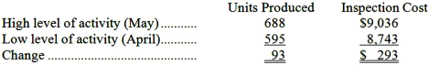  Variable cost per unit = Change in cost ÷ Change in activity  = $293 ÷ 93 units  = $3.15 per unit

AACSB: Analytic
AICPA BB: Critical Thinking
AICPA FN: Measurement
Blooms: Apply
Learning Objective: 02-04 Analyze a mixed cost using a scattergraph plot and the high-low method.
Level: 1 Easy

125. | Using the high-low method, the estimate of the fixed component of inspection cost per month is closest to:  A. $8,743  B. $8,887  C. $8,683  D. $6,869  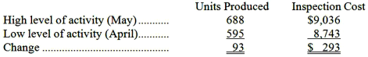  Variable cost per unit = Change in cost ÷ Change in activity  = $293 ÷ 93 units  = $3.15 per unit  Total fixed cost = Total cost - Variable cost element  = $9,036 - ($3.15 per unit × 688 units)  = $9,036 - $2,167  = $6,869

AACSB: Analytic
AICPA BB: Critical Thinking
AICPA FN: Measurement
Blooms: Apply
Learning Objective: 02-04 Analyze a mixed cost using a scattergraph plot and the high-low method.
Level: 1 Easy

Glatt Inc., an escrow agent, has provided the following data concerning its office expenses:
Management believes that office expense is a mixed cost that depends on the number of escrows completed. Note: Real estate purchases usually involve the services of an escrow agent that holds funds and prepares documents to complete the transaction.

126. | Using the high-low method, the estimate of the variable component of office expense per escrow completed is closest to:  A. $101.08  B. $59.12  C. $17.11  D. $17.15  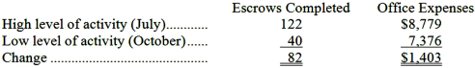  Variable cost per unit = Change in cost ÷ Change in activity  = $1,403 ÷ 82 escrows  = $17.11 per escrow

AACSB: Analytic
AICPA BB: Critical Thinking
AICPA FN: Measurement
Blooms: Apply
Learning Objective: 02-04 Analyze a mixed cost using a scattergraph plot and the high-low method.
Level: 1 Easy

127. | Using the high-low method, the estimate of the fixed component of office expense per month is closest to:  A. $6,692  B. $8,064  C. $7,376  D. $7,720  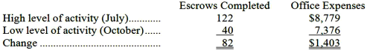  Variable cost per unit = Change in cost ÷ Change in activity  = $1,403 ÷ 82 escrows  = $17.11 per escrow  Total fixed cost = Total cost - Variable cost element  = $8,779 - ($17.11 per escrow × 122 escrows)  = $8,779 - $2,087  = $6,692

AACSB: Analytic
AICPA BB: Critical Thinking
AICPA FN: Measurement
Blooms: Apply
Learning Objective: 02-04 Analyze a mixed cost using a scattergraph plot and the high-low method.
Level: 1 Easy

Electrical costs at one of Reifel Corporation's factories are listed below:
Management believes that electrical cost is a mixed cost that depends on machine-hours.

128. | Using the high-low method, the estimate of the variable component of electrical cost per machine-hour is closest to:  A. $0.12  B. $20.38  C. $7.98  D. $8.22  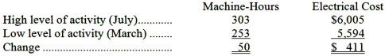  Variable cost per unit = Change in cost ÷ Change in activity  = $411 ÷ 50 machine-hours  = $8.22 per machine hour

AACSB: Analytic
AICPA BB: Critical Thinking
AICPA FN: Measurement
Blooms: Apply
Learning Objective: 02-04 Analyze a mixed cost using a scattergraph plot and the high-low method.
Level: 1 Easy

129. | Using the high-low method, the estimate of the fixed component of electrical cost per month is closest to:  A. $5,594  B. $3,514  C. $5,875  D. $5,840  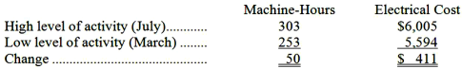  Variable cost per unit = Change in cost ÷ Change in activity  = $411 ÷ 50 machine-hours  = $8.22 per machine hour  Total fixed cost = Total cost - Variable cost element  = $6,005 - ($8.22 per machine-hour × 303 machine-hours)  = $6,005 - $2,491  = $3,514

AACSB: Analytic
AICPA BB: Critical Thinking
AICPA FN: Measurement
Blooms: Apply
Learning Objective: 02-04 Analyze a mixed cost using a scattergraph plot and the high-low method.
Level: 1 Easy

The following data have been provided by a retailer that sells a single product.

130. | What is the best estimate of the company's variable selling and administrative expense per unit?  A. $4.17 per unit  B. $0.24 per unit  C. $0.90 per unit  D. $0.71 per unit  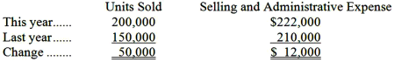  Variable cost per unit = Change in cost ÷ Change in activity  = $12,000 ÷ 50,000 units sold  = $0.24 per unit sold

AACSB: Analytic
AICPA BB: Critical Thinking
AICPA FN: Measurement
Blooms: Apply
Learning Objective: 02-04 Analyze a mixed cost using a scattergraph plot and the high-low method.
Level: 2 Medium

131. | What is the best estimate of the company's total fixed selling and administrative expense per year?  A. $0  B. $80,000  C. $44,000  D. 174,000  Total fixed cost = Total cost - Variable cost element  = $222,000 - ($0.24 per unit sold × 200,000 units sold)  = $222,000 - $48,000  = $174,000

AACSB: Analytic
AICPA BB: Critical Thinking
AICPA FN: Measurement
Blooms: Apply
Learning Objective: 02-04 Analyze a mixed cost using a scattergraph plot and the high-low method.
Level: 2 Medium

132. | What is the best estimate of the company's contribution margin for this year?  A. $252,000  B. $300,000  C. $158,000  D. $120,000  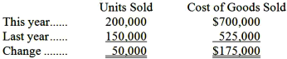  Variable cost per unit = Change in cost ÷ Change in activity  = $175,000 ÷ 50,000 units sold  = $3.50 per unit sold  Total fixed cost = Total cost - Variable cost element  = $700,000 - ($3.50 per unit sold × 200,000 units sold)  = $700,000 - $700,000  = $0  Selling price per unit = Sales revenue ÷ Units sold  = $1,000,000 ÷ 200,000 units sold  = $5.00 per unit sold  Total contribution margin = Total sales revenue - Total variable cost  = $1,000,000 - ($700,000 + $48,000)  = $1,000,000 - $748,000  = $252,000

AACSB: Analytic
AICPA BB: Critical Thinking
AICPA FN: Measurement
Blooms: Apply
Learning Objective: 02-04 Analyze a mixed cost using a scattergraph plot and the high-low method.
Level: 3 Hard

Nikkel Corporation, a merchandising company, reported the following results for July:

133. | The gross margin for July is:  A. $358,500  B. $209,000  C. $233,700  D. $164,700  Gross margin = Total sales - Cost of goods sold  = $402,800 - $169,100  = $233,700

AACSB: Analytic
AICPA BB: Critical Thinking
AICPA FN: Measurement
Blooms: Apply
Learning Objective: 02-05 Prepare income statements for a merchandising company using the traditional and contribution formats.
Level: 1 Easy

134. | The contribution margin for July is:  A. $333,800  B. $209,000  C. $233,700  D. $164,700  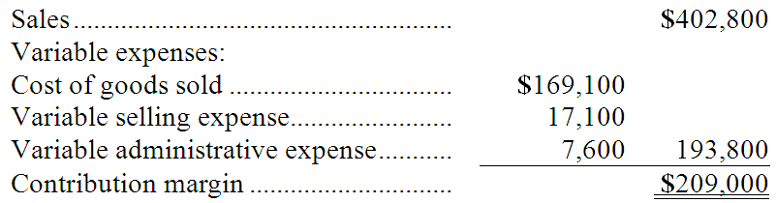

AACSB: Analytic
AICPA BB: Critical Thinking
AICPA FN: Measurement
Blooms: Apply
Learning Objective: 02-05 Prepare income statements for a merchandising company using the traditional and contribution formats.
Level: 1 Easy

Holzhauer Corporation, a merchandising company, reported the following results for March:
Cost of goods sold is a variable cost in this company.

135. | The gross margin for March is:  A. $922,600  B. $1,120,000  C. $2,202,600  D. $1,360,000  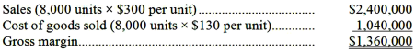

AACSB: Analytic
AICPA BB: Critical Thinking
AICPA FN: Measurement
Blooms: Apply
Learning Objective: 02-05 Prepare income statements for a merchandising company using the traditional and contribution formats.
Level: 2 Medium

136. | The contribution margin for March is:  A. $922,600  B. $1,120,000  C. $1,962,600  D. $1,360,000  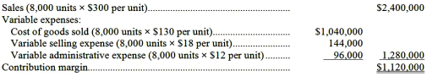

AACSB: Analytic
AICPA BB: Critical Thinking
AICPA FN: Measurement
Blooms: Apply
Learning Objective: 02-05 Prepare income statements for a merchandising company using the traditional and contribution formats.
Level: 2 Medium

Fiene Sales, Inc., a merchandising company, reported sales of 2,200 units in June at a selling price of $600 per unit. Cost of goods sold, which is a variable cost, was $364 per unit. Variable selling expenses were $23 per unit and variable administrative expenses were $33 per unit. The total fixed selling expenses were $30,500 and the total administrative expenses were $55,300.

137. | The contribution margin for June was:  A. $1,111,000  B. $396,000  C. $310,200  D. $519,200  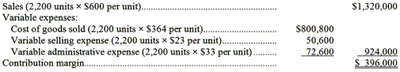

AACSB: Analytic
AICPA BB: Critical Thinking
AICPA FN: Measurement
Blooms: Apply
Learning Objective: 02-05 Prepare income statements for a merchandising company using the traditional and contribution formats.
Level: 2 Medium

138. | The gross margin for June was:  A. $310,200  B. $1,234,200  C. $396,000  D. $519,200  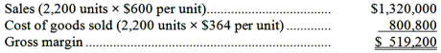

AACSB: Analytic
AICPA BB: Critical Thinking
AICPA FN: Measurement
Blooms: Apply
Learning Objective: 02-05 Prepare income statements for a merchandising company using the traditional and contribution formats.
Level: 2 Medium

Getchman Marketing, Inc., a merchandising company, reported sales of $592,500 and cost of goods sold of $305,000 for April. The company's total variable selling expense was $37,500; its total fixed selling expense was $16,000; its total variable administrative expense was $35,000; and its total fixed administrative expense was $38,900. The cost of goods sold in this company is a variable cost.

139. | The contribution margin for April is:  A. $465,100  B. $287,500  C. $160,100  D. $215,000  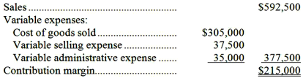

AACSB: Analytic
AICPA BB: Critical Thinking
AICPA FN: Measurement
Blooms: Apply
Learning Objective: 02-05 Prepare income statements for a merchandising company using the traditional and contribution formats.
Level: 1 Easy

140. | The gross margin for April is:  A. $287,500  B. $215,000  C. $537,600  D. $160,100  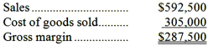

AACSB: Analytic
AICPA BB: Critical Thinking
AICPA FN: Measurement
Blooms: Apply
Learning Objective: 02-05 Prepare income statements for a merchandising company using the traditional and contribution formats.
Level: 1 Easy

Salvadore Inc., a local retailer, has provided the following data for the month of September:

141. | The cost of goods sold for September was:  A. $132,000  B. $134,000  C. $133,000  D. $200,000  Cost of goods sold = Beginning merchandise inventory + Purchases of merchandise inventory - Ending merchandise inventory  = $42,000 + $133,000 - $41,000  = $134,000

AACSB: Analytic
AICPA BB: Critical Thinking
AICPA FN: Measurement
Blooms: Apply
Learning Objective: 02-05 Prepare income statements for a merchandising company using the traditional and contribution formats.
Level: 1 Easy

142. | The net operating income for September was:  A. $60,000  B. $128,000  C. $127,000  D. $59,000  Net operating income = Sales - Cost of goods sold - Selling and administrative expenses  = $260,000 - $134,000 - ($15,000 + $52,000)  = $59,000

AACSB: Analytic
AICPA BB: Critical Thinking
AICPA FN: Measurement
Blooms: Apply
Learning Objective: 02-05 Prepare income statements for a merchandising company using the traditional and contribution formats.
Level: 1 Easy

The following cost data pertain to the operations of Swestka Department Stores, Inc., for the month of July.
The Northridge Store is just one of many stores owned and operated by the company. The Cosmetics Department is one of many departments at the Northridge Store. The central warehouse serves all of the company's stores.

143. | What is the total amount of the costs listed above that are direct costs of the Cosmetics Department?  A. $74,000  B. $36,000  C. $31,000  D. $40,000  Direct costs of the Cosmetics Department = Cosmetics Department sales commissions + Cosmetics Department cost of sales + Cosmetics Department manager's salary  = $5,000 + $31,000 + $4,000  = $40,000

AACSB: Analytic
AICPA BB: Critical Thinking
AICPA FN: Measurement
Blooms: Apply
Learning Objective: 02-06 Understand the differences between direct and indirect costs.
Level: 1 Easy

144. | What is the total amount of the costs listed above that are NOT direct costs of the Northridge Store?  A. $40,000  B. $34,000  C. $141,000  D. $78,000  Costs that are not direct costs of the Northridge Store = Corporate headquarters building lease + Corporate legal office salaries + Central warehouse lease cost  = $78,000 + $57,000 + $6,000  = $141,000

AACSB: Analytic
AICPA BB: Critical Thinking
AICPA FN: Measurement
Blooms: Apply
Learning Objective: 02-06 Understand the differences between direct and indirect costs.
Level: 2 Medium

The following cost data pertain to the operations of Mancia Department Stores, Inc., for the month of February.
The Brentwood Store is just one of many stores owned and operated by the company. The Shoe Department is one of many departments at the Brentwood Store. The central warehouse serves all of the company's stores.

145. | What is the total amount of the costs listed above that are direct costs of the Shoe Department?  A. $80,000  B. $88,000  C. $130,000  D. $92,000  Direct costs of the Shoe Department = Shoe Department cost of sales + Shoe Department sales commissions + Shoe Department manager's salary  = $80,000 + $8,000 + $4,000  = $92,000

AACSB: Analytic
AICPA BB: Critical Thinking
AICPA FN: Measurement
Blooms: Apply
Learning Objective: 02-06 Understand the differences between direct and indirect costs.
Level: 1 Easy

146. | What is the total amount of the costs listed above that are NOT direct costs of the Brentwood Store?  A. $152,000  B. $92,000  C. $79,000  D. $38,000  Costs that are not direct costs of the Brentwood Store = Corporate legal office salaries + Corporate headquarters building lease + Central warehouse lease cost  = $62,000 + $79,000 + $11,000  = $152,000

AACSB: Analytic
AICPA BB: Critical Thinking
AICPA FN: Measurement
Blooms: Apply
Learning Objective: 02-06 Understand the differences between direct and indirect costs.
Level: 2 Medium

Management of Modugno Corporation is considering whether to purchase a new model 370 machine costing $441,000 or a new model 240 machine costing $387,000 to replace a machine that was purchased 7 years ago for $429,000. The old machine was used to make product M25A until it broke down last week. Unfortunately, the old machine cannot be repaired.
Management has decided to buy the new model 240 machine. It has less capacity than the new model 370 machine, but its capacity is sufficient to continue making product M25A.
Management also considered, but rejected, the alternative of simply dropping product M25A. If that were done, instead of investing $387,000 in the new machine, the money could be invested in a project that would return a total of $430,000.

147. | In making the decision to buy the model 240 machine rather than the model 370 machine, the sunk cost was:  A. $430,000  B. $429,000  C. $387,000  D. $441,000  The $429,000 cost of the old machine is a sunk cost.

AACSB: Analytic
AICPA BB: Critical Thinking
AICPA FN: Decision Making
Blooms: Apply
Learning Objective: 02-07 Understand cost classifications used in making decisions: differential costs; opportunity costs; and sunk costs.
Level: 1 Easy

148. | In making the decision to buy the model 240 machine rather than the model 370 machine, the differential cost was:  A. $12,000  B. $1,000  C. $54,000  D. $42,000  Differential cost = $441,000 - $387,000 = $54,000

AACSB: Analytic
AICPA BB: Critical Thinking
AICPA FN: Decision Making
Blooms: Apply
Learning Objective: 02-07 Understand cost classifications used in making decisions: differential costs; opportunity costs; and sunk costs.
Level: 1 Easy

149. | In making the decision to invest in the model 240 machine, the opportunity cost was:  A. $430,000  B. $441,000  C. $387,000  D. $429,000  The $430,000 return from alternative investment is an opportunity cost.

AACSB: Analytic
AICPA BB: Critical Thinking
AICPA FN: Decision Making
Blooms: Apply
Learning Objective: 02-07 Understand cost classifications used in making decisions: differential costs; opportunity costs; and sunk costs.
Level: 1 Easy

Temblador Corporation purchased a machine 7 years ago for $319,000 when it launched product E26T. Unfortunately, this machine has broken down and cannot be repaired. The machine could be replaced by a new model 330 machine costing $323,000 or by a new model 230 machine costing $285,000. Management has decided to buy the model 230 machine. It has less capacity than the model 330 machine, but its capacity is sufficient to continue making product E26T. Management also considered, but rejected, the alternative of dropping product E26T and not replacing the old machine. If that were done, the $285,000 invested in the new machine could instead have been invested in a project that would have returned a total of $386,000.

150. | In making the decision to buy the model 230 machine rather than the model 330 machine, the differential cost was:  A. $34,000  B. $38,000  C. $4,000  D. $67,000  Differential cost = $323,000 - $285,000 = $38,000

AACSB: Analytic
AICPA BB: Critical Thinking
AICPA FN: Decision Making
Blooms: Apply
Learning Objective: 02-07 Understand cost classifications used in making decisions: differential costs; opportunity costs; and sunk costs.
Level: 1 Easy

151. | In making the decision to buy the model 230 machine rather than the model 330 machine, the sunk cost was:  A. $319,000  B. $386,000  C. $285,000  D. $323,000  The $319,000 cost of the old machine is a sunk cost.

AACSB: Analytic
AICPA BB: Critical Thinking
AICPA FN: Decision Making
Blooms: Apply
Learning Objective: 02-07 Understand cost classifications used in making decisions: differential costs; opportunity costs; and sunk costs.
Level: 1 Easy

152. | In making the decision to invest in the model 230 machine, the opportunity cost was:  A. $386,000  B. $319,000  C. $285,000  D. $323,000  The $386,000 return from alternative investment is an opportunity cost.

AACSB: Analytic
AICPA BB: Critical Thinking
AICPA FN: Decision Making
Blooms: Apply
Learning Objective: 02-07 Understand cost classifications used in making decisions: differential costs; opportunity costs; and sunk costs.
Level: 1 Easy

Essay Questions
153. | Bill Pope has developed a new device that is so exciting he is considering quitting his job in order to produce and market it on a large-scale basis. Bill will rent a garage for $300 per month for production purposes. Utilities will cost $40 per month. Bill has already taken an industrial design course at the local community college to help prepare for this venture. The course cost $300. Bill will rent production equipment at a monthly cost of $800. He estimates the material cost per unit will be $5, and the labor cost will be $3. He will hire workers and spend his time promoting the product. To do this he will quit his job which pays $3,000 per month. Advertising and promotion will cost $900 per month.  Required:  Complete the chart below by placing an "X" under each heading that helps to identify the cost involved. There can be "Xs" placed under more than one heading for a single cost, e.g., a cost might be a sunk cost, an overhead cost and a product cost; there would be an "X" placed under each of these headings opposite the cost.  * Between the alternatives of going into business to make the device or not going into business to make the device.  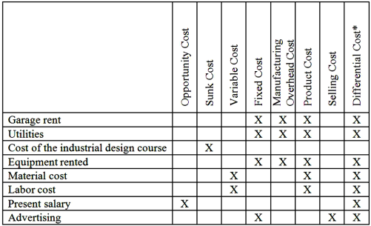

AACSB: Reflective Thinking
AICPA BB: Critical Thinking
AICPA FN: Decision Making
Blooms: Apply
Learning Objective: 02-01 Identify and give examples of each of the three basic manufacturing cost categories.
Learning Objective: 02-02 Distinguish between product cost and period costs and give examples of each.
Learning Objective: 02-03 Understand cost behavior patterns including variable costs; fixed costs; and mixed costs.
Learning Objective: 02-07 Understand cost classifications used in making decisions: differential costs; opportunity costs; and sunk costs.
Level: 2 Medium

154. | Laco Company acquired its factory building about 20 years ago. For a number of years the company has rented out a small, unused part of the building. The renter's lease will expire soon. Rather than renewing the lease, Laco Company is considering using the space itself to manufacture a new product. Under this option, the unused space will continue to be depreciated on a straight-line basis, as in past years.  Direct materials and direct labor cost for the new product would be $50 per unit. In order to have a place to store finished units of the new product, the company would have to rent a small warehouse nearby. The rental cost would be $2,000 per month. It would cost the company an additional $4,000 each month to advertise the new product. A new production supervisor would be hired to oversee production of the new product who would be paid $3,000 per month. The company would pay a sales commission of $10 for each unit of product that is sold.  Required:  Complete the chart below by placing an "X" under each column heading that helps to identify the costs listed to the left. There can be "X's" placed under more than one heading for a single cost. For example, a cost might be a product cost, an opportunity cost, and a sunk cost; there would be an "X" placed under each of these headings on the answer sheet opposite the cost.  *Between the alternatives of (1) renting the space out again or (2) using the space to produce the new product.  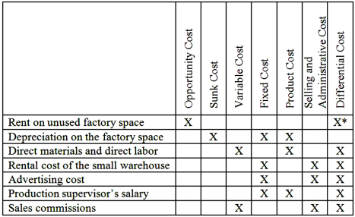  * We suggest you allow either answer (a blank or an X) in this cell. Some would consider an opportunity cost to be a differential cost and others would not. It is all a matter of definition and the definitions given in the text do not really cover this contingency.

AACSB: Reflective Thinking
AICPA BB: Critical Thinking
AICPA FN: Decision Making
Blooms: Apply
Learning Objective: 02-02 Distinguish between product cost and period costs and give examples of each.
Learning Objective: 02-03 Understand cost behavior patterns including variable costs; fixed costs; and mixed costs.
Learning Objective: 02-07 Understand cost classifications used in making decisions: differential costs; opportunity costs; and sunk costs.
Level: 2 Medium

155. | Lettman Corporation has provided the following partial listing of costs incurred during November:  Required:  a. What is the total amount of product cost listed above? Show your work.  b. What is the total amount of period cost listed above? Show your work.  a. Product costs consist of direct materials, direct labor, and manufacturing overhead:  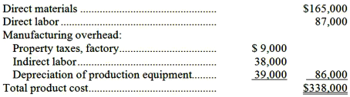  b. Period costs consist of all costs other than product costs:  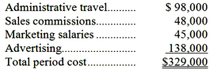

AACSB: Analytic
AICPA BB: Critical Thinking
AICPA FN: Measurement
Blooms: Apply
Learning Objective: 02-02 Distinguish between product cost and period costs and give examples of each.
Level: 2 Medium

156. | A partial listing of costs incurred at Starr Corporation during June appears below:  Required:  a. What is the total amount of product cost listed above? Show your work.  b. What is the total amount of period cost listed above? Show your work.  a. Product costs consist of direct materials, direct labor, and manufacturing overhead:  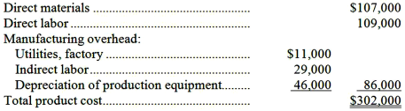  b. Period costs consist of all costs other than product costs:  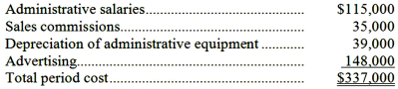

AACSB: Analytic
AICPA BB: Critical Thinking
AICPA FN: Measurement
Blooms: Apply
Learning Objective: 02-02 Distinguish between product cost and period costs and give examples of each.
Level: 2 Medium

157. | The following information summarizes the company's cost structure:  Required:  Estimate the following costs at the 40,000 unit level of activity:  a. Total variable cost.  b. Total fixed cost.  c. Variable cost per unit.  d. Fixed cost per unit.  Parts a., b., c., & d.  Note: The total fixed cost is 48,000 units × $4.50 per unit = $216,000.  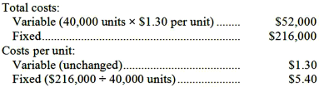

AACSB: Analytic
AICPA BB: Critical Thinking
AICPA FN: Measurement
Blooms: Apply
Learning Objective: 02-03 Understand cost behavior patterns including variable costs; fixed costs; and mixed costs.
Level: 1 Easy

158. | Corio Corporation reports that at an activity level of 3,800 units, its total variable cost is $221,464 and its total fixed cost is $94,848.  Required:  For the activity level of 3,900 units, compute: (a) the total variable cost; (b) the total fixed cost; (c) the total cost; (d) the average variable cost per unit; (e) the average fixed cost per unit; and (f) the average total cost per unit. Assume that this activity level is within the relevant range.  Variable cost = $221,464 ÷ 3,800 units = $58.28 per unit  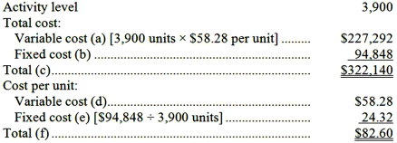

AACSB: Analytic
AICPA BB: Critical Thinking
AICPA FN: Measurement
Blooms: Apply
Learning Objective: 02-03 Understand cost behavior patterns including variable costs; fixed costs; and mixed costs.
Level: 1 Easy

159. | At an activity level of 5,900 units, Haas Corporation's total variable cost is $347,982 and its total fixed cost is $284,321.  Required:  For the activity level of 6,100 units, compute: (a) the total variable cost; (b) the total fixed cost; (c) the total cost; (d) the average variable cost per unit; (e) the average fixed cost per unit; and (f) the average total cost per unit. Assume that this activity level is within the relevant range.  Variable cost = $347,982 ÷ 5,900 units = $58.98 per unit  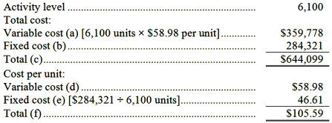

AACSB: Analytic
AICPA BB: Critical Thinking
AICPA FN: Measurement
Blooms: Apply
Learning Objective: 02-03 Understand cost behavior patterns including variable costs; fixed costs; and mixed costs.
Level: 1 Easy

160. | A number of costs and measures of activity are listed below.  Required:  For each item above, indicate whether the cost is MAINLY fixed or variable with respect to the possible measure of activity listed next to it.  1. Insurance on a warehouse building at a computer retailer; Number of items stocked; Fixed  2. Cost of solder used in making computers; Computers produced; Variable  3. Cost of heating an electronics store; Dollar sales; Fixed  4. Cost of testing materials used in a medical lab; Tests run; Variable  5. Cost of electricity for production equipment at a surfboard manufacturer; Surfboards produced; Variable  6. Cost of airplane fuel at a regularly scheduled commuter airline; Number of passengers; Fixed  7. Sales commissions at a cell phone dealer; Dollar sales; Variable  8. Cost of renting production equipment on a monthly basis at a surfboard manufacturer; Surfboards produced; Fixed  9. Cook's wages at a coffee shop; Dollar sales; Fixed  10. Shift manager's wages at a coffee shop; Dollar sales; Fixed

AACSB: Reflective Thinking
AICPA BB: Critical Thinking
AICPA FN: Measurement
Blooms: Apply
Learning Objective: 02-03 Understand cost behavior patterns including variable costs; fixed costs; and mixed costs.
Level: 1 Easy

161. | A number of costs and measures of activity are listed below.  Required:  For each item above, indicate whether the cost is MAINLY fixed or variable with respect to the possible measure of activity listed next to it.  1. Cost of direct materials used to make furniture; Units produced; Variable  2. Cost of vaccine used at a clinic; Vaccines administered; Variable  3. Cost of renting production equipment on a monthly basis at a snowboard manufacturer; Snowboards produced; Fixed  4. Shift manager's wages at a taco shop; Dollar sales; Fixed  5. Dental hygiene supplies at a dentist's office; Number of patients; Variable  6. Cost of heating a hardware store; Dollar sales; Fixed  7. Sales commissions at an auto dealer; Dollar sales; Variable  8. Cost of electricity for production equipment at a snowboard manufacturer; Snowboards produced; Variable  9. Cost of cement used to produce cinder blocks; Cinder blocks produced; Variable  10. Ferry captain's salary on a regularly scheduled passenger ferry; Number of passengers; Fixed

AACSB: Reflective Thinking
AICPA BB: Critical Thinking
AICPA FN: Measurement
Blooms: Apply
Learning Objective: 02-03 Understand cost behavior patterns including variable costs; fixed costs; and mixed costs.
Level: 1 Easy

162. | Slonaker Inc. has provided the following data concerning its maintenance costs:  Management believes that maintenance cost is a mixed cost that depends on machine-hours.  Required:  Estimate the variable cost per machine-hour and the fixed cost per month using the high-low method. Show your work!  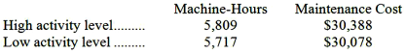  Variable cost = Change in cost ÷ Change in activity  = ($30,388 - $30,078) ÷ (5,809 machine-hours - 5,717 machine-hours)  = $310 ÷ 92 machine-hours  = $3.37 per machine-hour  Fixed cost element = Total cost - Variable cost element  = $30,078 - ($3.37 per machine-hour × 5,717 machine-hours)  = $10,812

AACSB: Analytic
AICPA BB: Critical Thinking
AICPA FN: Measurement
Blooms: Apply
Learning Objective: 02-04 Analyze a mixed cost using a scattergraph plot and the high-low method.
Level: 1 Easy

163. | Utility costs at one of Helker Corporation's factories are listed below:  Management believes that utility cost is a mixed cost that depends on machine-hours.  Required:  Estimate the variable cost per machine-hour and the fixed cost per month using the high-low method. Show your work! Round off all calculations to the nearest whole cent.  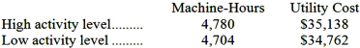  Variable cost = Change in cost ÷ Change in activity  = ($35,138 - $34,762) ÷ (4,780 machine-hours - 4,704 machine-hours)  = $376 ÷ 76 machine-hours  = $4.95 per machine-hour  Fixed cost element = Total cost - Variable cost element  = $34,762 - ($4.95 per machine-hour × 4,704 machine-hours)  = $34,762.00 - $23,284.80  = $11,477.20

AACSB: Analytic
AICPA BB: Critical Thinking
AICPA FN: Measurement
Blooms: Apply
Learning Objective: 02-04 Analyze a mixed cost using a scattergraph plot and the high-low method.
Level: 1 Easy

164. | The management of Harrigill Corporation would like to have a better understanding of the behavior of its inspection costs. The company has provided the following data:  Management believes that inspection cost is a mixed cost that depends on direct labor-hours.  Required:  Estimate the variable cost per direct labor-hour and the fixed cost per month using the high-low method. Show your work! Round off all calculations to the nearest whole cent.  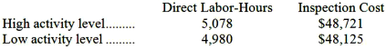  Variable cost = Change in cost ÷ Change in activity  = ($48,721 - $48,125) ÷ (5,078 direct labor-hours - 4,980 direct labor-hours)  = $596 ÷ 98 direct labor-hours  = $6.08  Fixed cost element = Total cost - Variable cost element  = $48,125 - ($6.08 per direct labor-hour × 4,980 direct labor-hours)  = $48,125.00 - $30,278.40  = $17,846.60

AACSB: Analytic
AICPA BB: Critical Thinking
AICPA FN: Measurement
Blooms: Apply
Learning Objective: 02-04 Analyze a mixed cost using a scattergraph plot and the high-low method.
Level: 1 Easy

165. | In October, Patnode Inc., a merchandising company, had sales of $294,000, selling expenses of $27,000, and administrative expenses of $35,000. The cost of merchandise purchased during the month was $211,000. The beginning balance in the merchandise inventory account was $38,000 and the ending balance was $34,000.  Required:  Prepare a traditional format income statement for October.  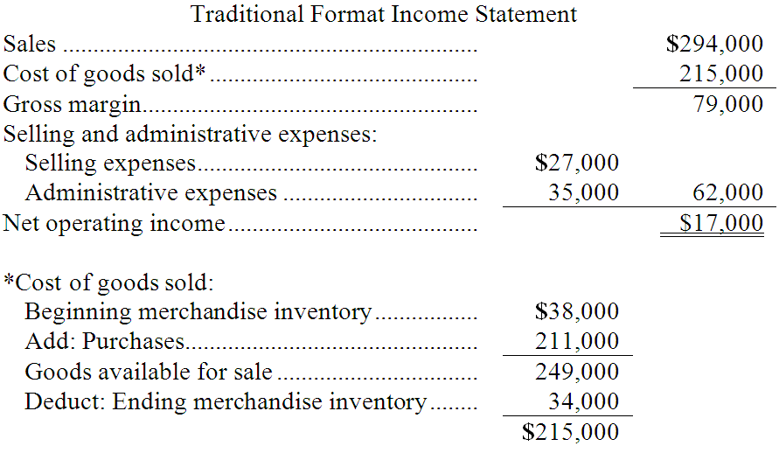

AACSB: Analytic
AICPA BB: Critical Thinking
AICPA FN: Measurement
Blooms: Apply
Learning Objective: 02-05 Prepare income statements for a merchandising company using the traditional and contribution formats.
Level: 1 Easy

166. | Whitman Corporation, a merchandising company, reported sales of 7,400 units for May at a selling price of $677 per unit. The cost of goods sold (all variable) was $441 per unit and the variable selling expense was $54 per unit. The total fixed selling expense was $155,600. The variable administrative expense was $24 per unit and the total fixed administrative expense was $370,400.  Required:  a. Prepare a contribution format income statement for May.  b. Prepare a traditional format income statement for May.  a. Contribution Format Income Statement  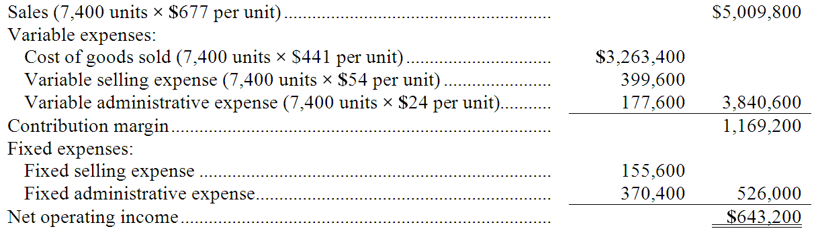  b. Traditional Format Income Statement  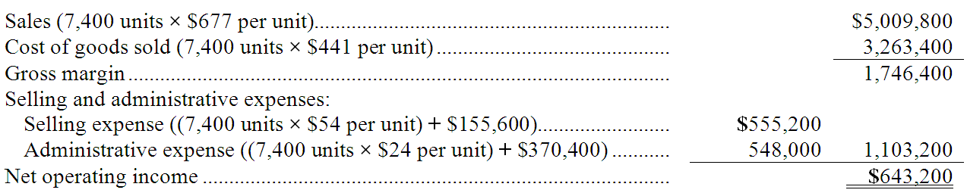

AACSB: Analytic
AICPA BB: Critical Thinking
AICPA FN: Measurement
Blooms: Apply
Learning Objective: 02-05 Prepare income statements for a merchandising company using the traditional and contribution formats.
Level: 2 Medium

167. | Donmoyer Sales Corporation, a merchandising company, reported total sales of $2,230,200 for May. The cost of goods sold (all variable) was $1,518,300, the total variable selling expense was $214,200, the total fixed selling expense was $86,700, the total variable administrative expense was $119,700, and the total fixed administrative expense was $138,400.  Required:  a. Prepare a contribution format income statement for May.  b. Prepare a traditional format income statement for May.  a. Contribution Format Income Statement  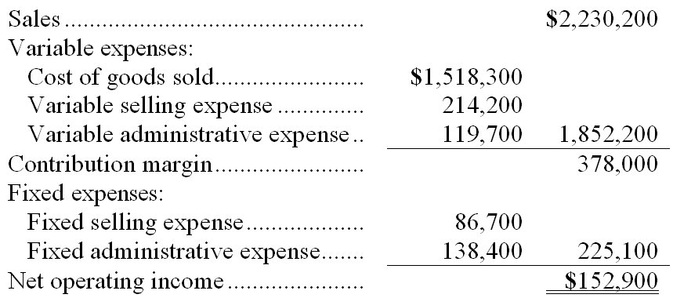  b. Traditional Format Income Statement  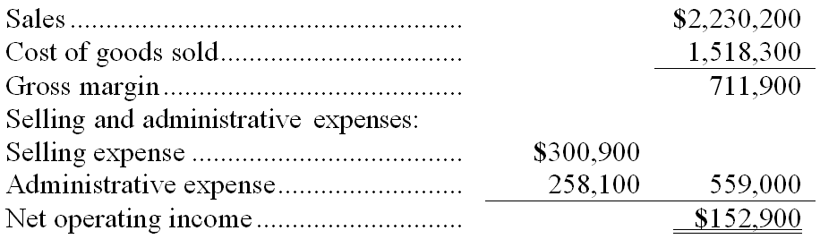

AACSB: Analytic
AICPA BB: Critical Thinking
AICPA FN: Measurement
Blooms: Apply
Learning Objective: 02-05 Prepare income statements for a merchandising company using the traditional and contribution formats.
Level: 1 Easy

168. | Pittman Corporation, a merchandising company, reported the following results for September:  Required:  a. Prepare a traditional format income statement for September.  b. Prepare a contribution format income statement for September.  a. Traditional Format Income Statement  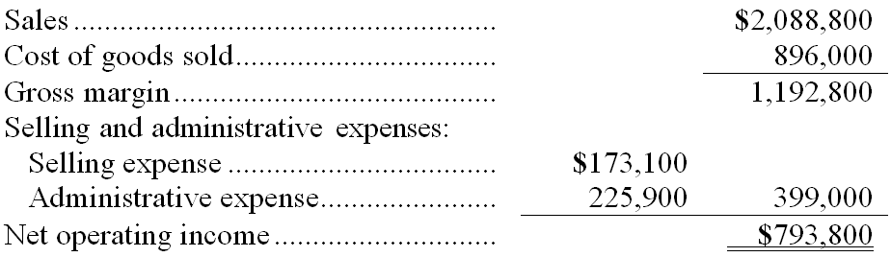  b. Contribution Format Income Statement  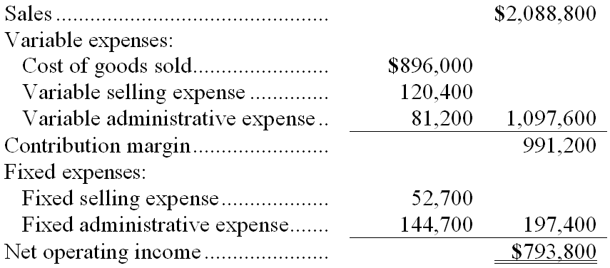

AACSB: Analytic
AICPA BB: Critical Thinking
AICPA FN: Measurement
Blooms: Apply
Learning Objective: 02-05 Prepare income statements for a merchandising company using the traditional and contribution formats.
Level: 1 Easy

169. | Honey Corporation, a merchandising company, reported the following results for January:  Cost of goods sold is a variable cost in this company.  Required:  a. Prepare a traditional format income statement for January.  b. Prepare a contribution format income statement for January.  a. Traditional Format Income Statement  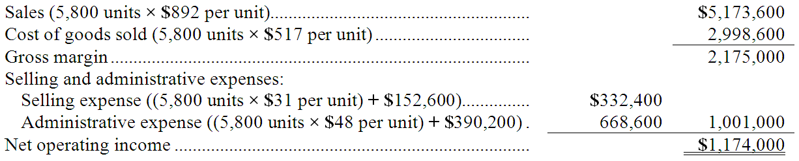  b. Contribution Format Income Statement  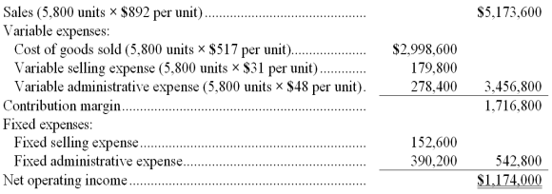

AACSB: Analytic
AICPA BB: Critical Thinking
AICPA FN: Measurement
Blooms: Apply
Learning Objective: 02-05 Prepare income statements for a merchandising company using the traditional and contribution formats.
Level: 2 Medium

170. | A number of costs are listed below.  Required:  For each item above, indicate whether the cost is direct or indirect with respect to the cost object listed next to it.  1. Wood used to build a home; A particular home; Direct  2. Cost of testing equipment in a computer manufacturing facility; A particular personal computer; Indirect  3. Cost of heating an outpatient clinic at a hospital; The outpatient clinic; Direct  4. Supervisor's wages in a computer manufacturing facility; A particular personal computer; Indirect  5. Monthly lease cost of X-ray equipment at a hospital; The Radiology (X-Ray) Department; Direct  6. Cost of tongue depressors used in an outpatient clinic at a hospital; The outpatient clinic; Direct  7. Monthly depreciation on construction tools used to build a home; A particular home; Indirect  8. Cost of wiring used in making a personal computer; A particular personal computer; Indirect  9. Cost of a measles vaccine administered at an outpatient clinic at a hospital; The outpatient clinic; Direct  10. Cost of heating a hotel run by a chain of hotels; A particular hotel guest; Indirect

AACSB: Reflective Thinking
AICPA BB: Critical Thinking
AICPA FN: Measurement
Blooms: Apply
Learning Objective: 02-06 Understand the differences between direct and indirect costs.
Level: 1 Easy

